**K PRASANTH (192211920) CSA0699 DAA**

1.FIBONACICCI SERIES USING RECURSION

#include <stdio.h>

int fibonacci(int n) {

if (n <= 1) {

return n;

}

return fibonacci(n - 1) + fibonacci(n - 2);

}

int main() {

int n, i;

printf("Enter the number of terms: ");

scanf("%d", &n);

printf("Fibonacci series: ");

for (i = 0; i < n; i++) {

printf("%d ", fibonacci(i));

}

return 0;

}

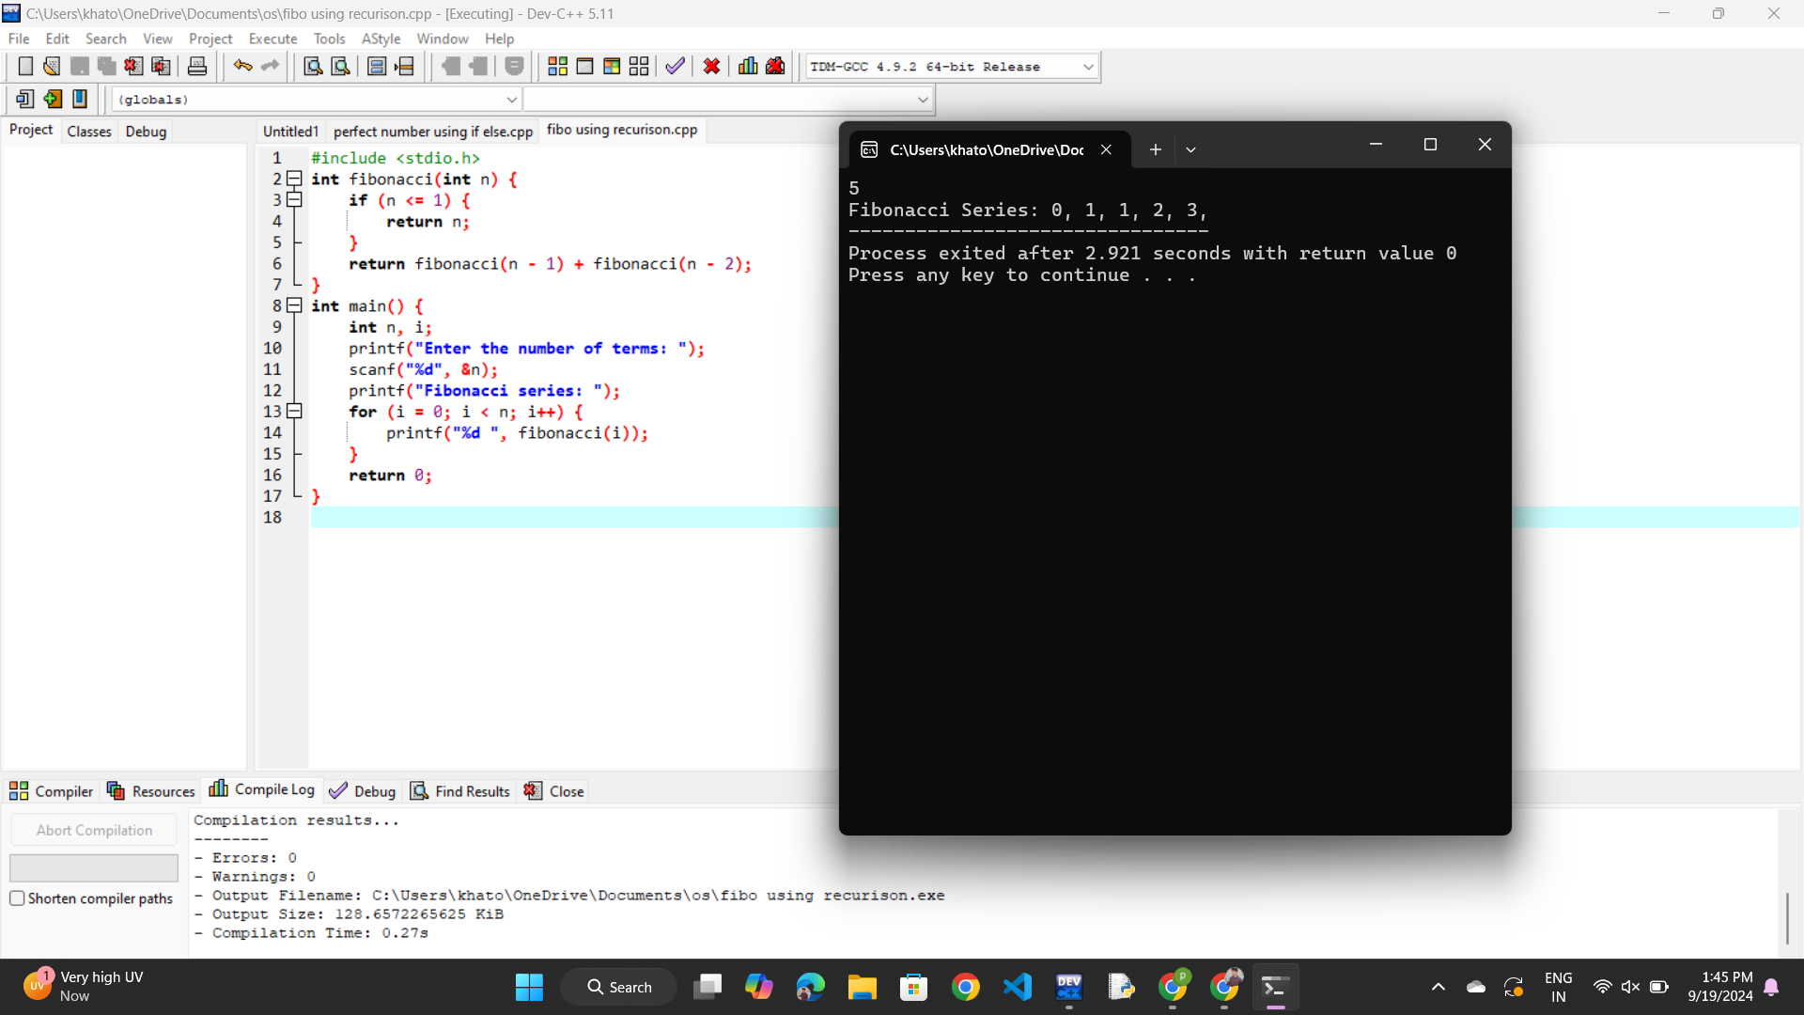

2. ARMSTRONG NUMBER

#include<stdio.h>

int main()

{

int num,originalNum,remainder,result=0;

scanf("%d",&num);

originalNum=num;

while(originalNum!=0)

{

remainder=originalNum%10;

result+=remainder*remainder*remainder;

originalNum/=10;

}

if(result==num)

printf("%d is an Armstrong number.",num);

else

printf("%d is not an Armstrong number.",num);

return 0;

}

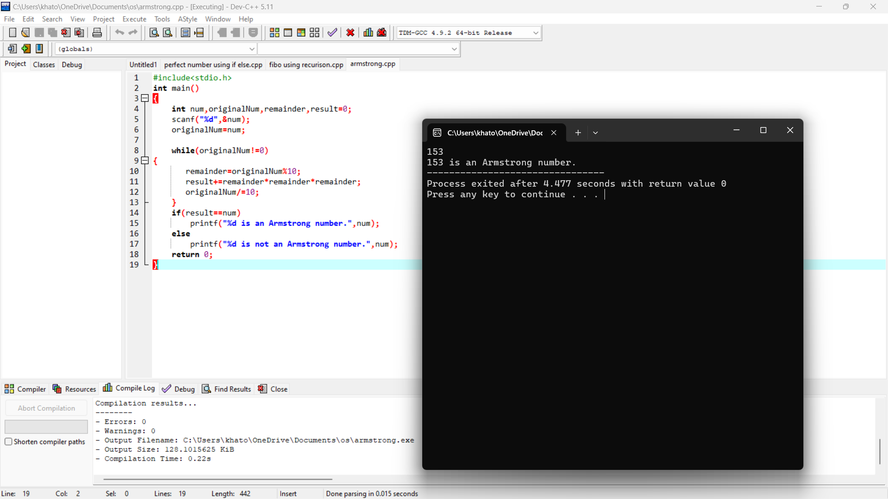

3. GCD OF TWO NUMBERS

#include <stdio.h>

int main()

{

int a,b;

printf("enter the two numbers:");

scanf("%d %d",&a,&b);

while(b){

int temp=b;

b=a%b;

a=temp;

}

printf("gcd is %d\n",a);

return 0;

}

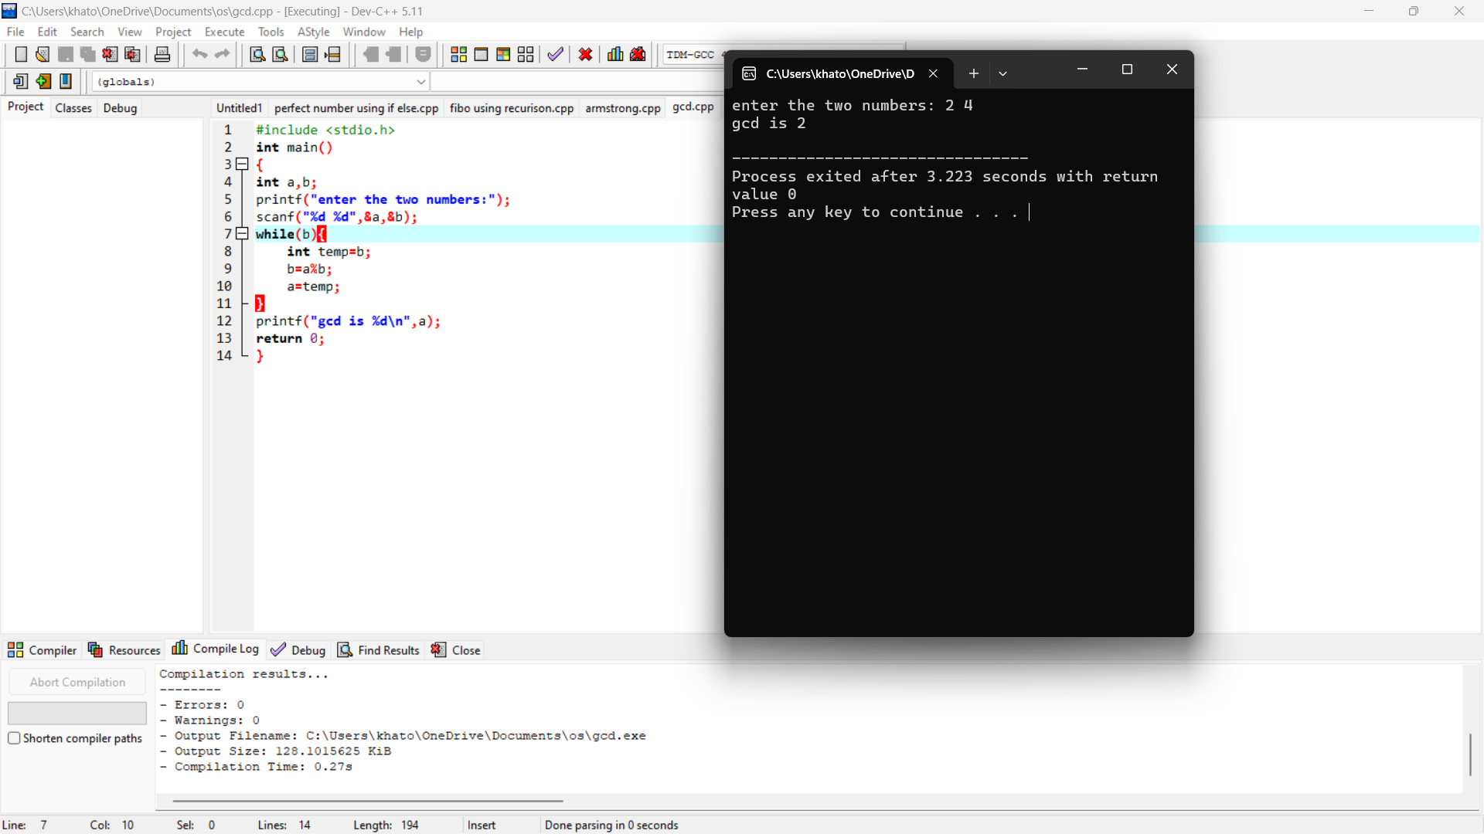

4. LARGEST ELEMENT IN AN ARRAY

#include <stdio.h>

int main() {

int n, i;

float arr[100];

printf("Enter the number of elements (up to 100): ");

scanf("%d", &n);

printf("Enter the elements:\n");

for (i = 0; i < n; i++) {

scanf("%f", &arr[i]);

}

float max = arr[0];

for (i = 1; i < n; i++) {

if (arr[i] > max) {

max = arr[i];

}

}

printf("The largest element is: %.2f\n", max);

return 0;

}

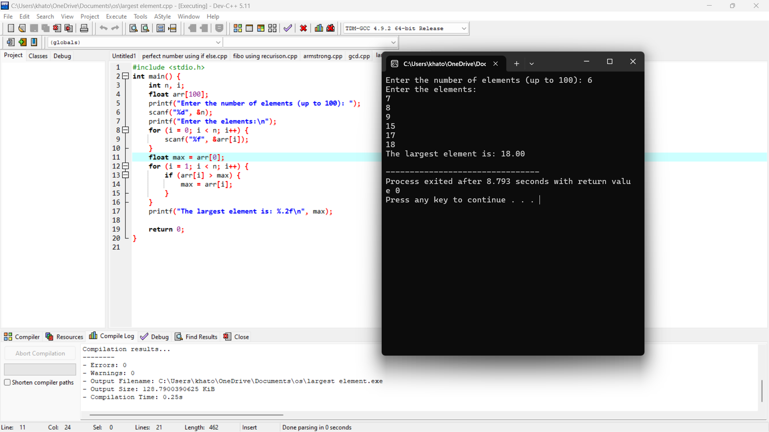

5. FACTORIAL

#include<stdio.h>

int main()

{

int num,fact=1;

printf("enter number:");

scanf("%d",&num);

for(int i=1;i<=num;i++){

fact=fact*i;

}

printf("%d\n",fact);

return 0;

}

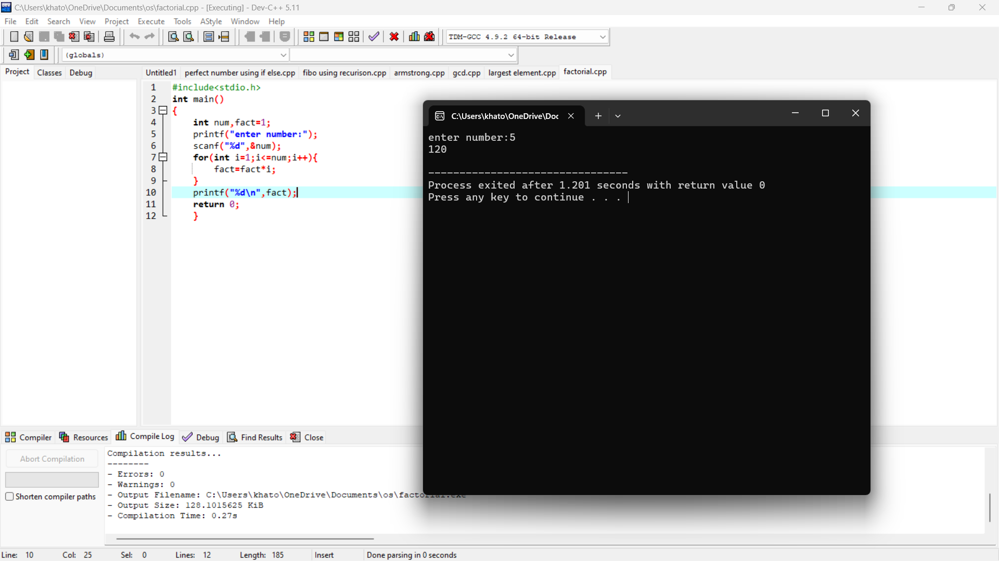

6. PRIME NUMBER

#include<stdio.h>

int main(){

int n,i,flag=0;

printf("enter a number");

scanf("%d",&n);

if(n==0||n==1)

flag=1;

for(i=2;i<=n/2;++i){

if(n%i==0){

flag=1;

break;

}

}

if(flag==0)

printf("%d is a prime",n);

else

printf("%d is a non prime",n);

return 0;

}

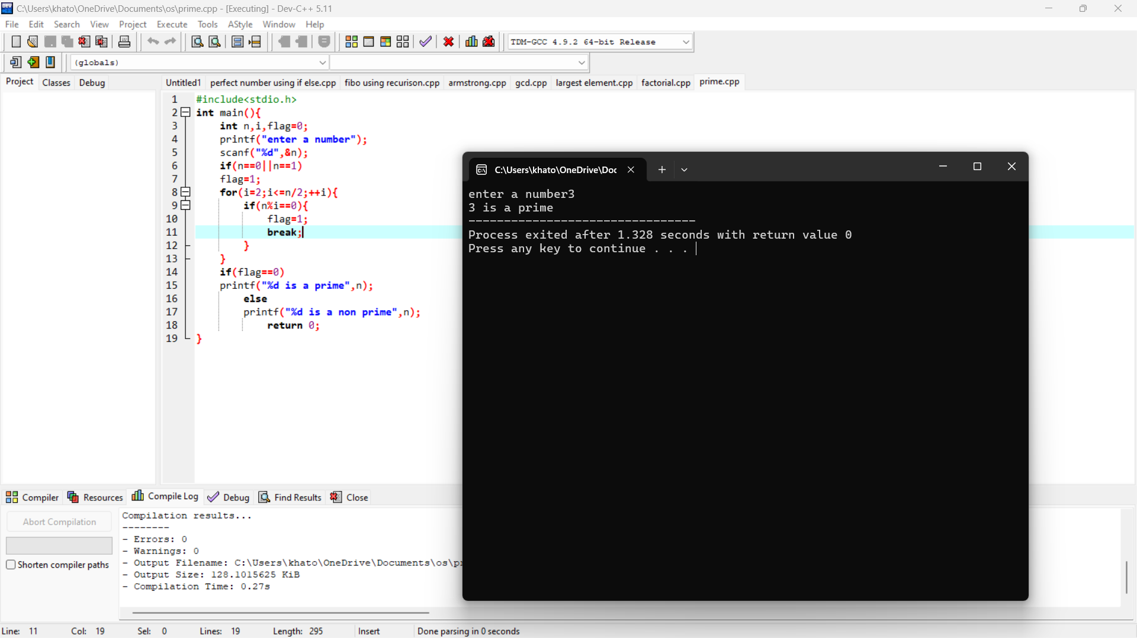

7. SELECTION SORT

#include <stdio.h>

void swap(int *a, int *b) {

int temp = *a;

*a = *b;

*b = temp;

}

void selectionSort(int arr[], int n) {

int i, j, minIndex;

for (i = 0; i < n-1; i++) {

minIndex = i;

for (j = i+1; j < n; j++) {

if (arr[j] < arr[minIndex]) {

minIndex = j;

}

}

swap(&arr[minIndex], &arr[i]);

}

}

void printArray(int arr[], int size) {

for (int i = 0; i < size; i++) {

printf("%d ", arr[i]);

}

printf("\n");

}

int main() {

int arr[] = {64, 25, 12, 22, 11};

int n = sizeof(arr)/sizeof(arr[0]);

printf("Original array: \n");

printArray(arr, n);

selectionSort(arr, n);

printf("Sorted array: \n");

printArray(arr, n);

return 0;

}

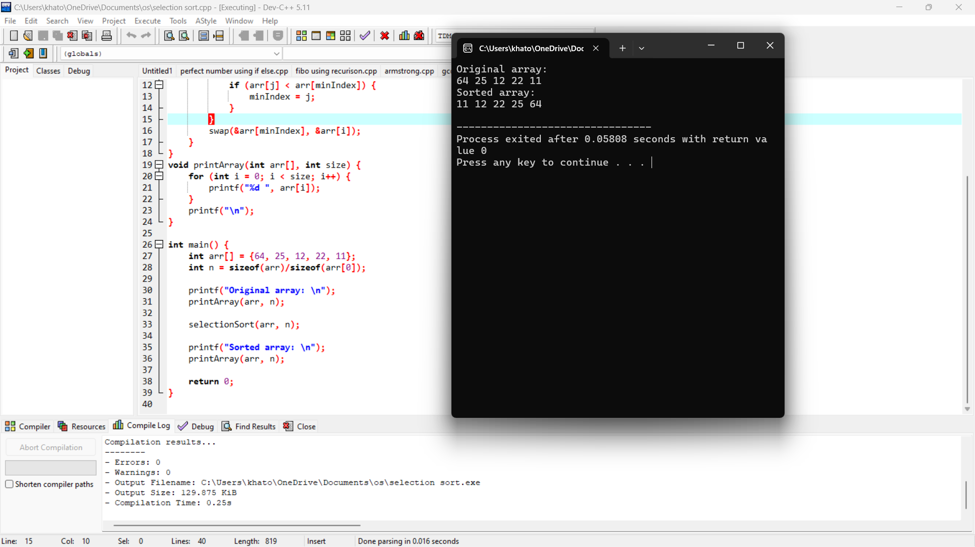

8. BUBBLE SORT

#include <stdio.h>

void bubbleSort(int arr[], int n) {

int i, j, temp;

for (i = 0; i < n-1; i++) {

for (j = 0; j < n-i-1; j++) {

if (arr[j] > arr[j+1]) {

temp = arr[j];

arr[j] = arr[j+1];

arr[j+1] = temp;

}

}

}

}

void printArray(int arr[], int n) {

for (int i = 0; i < n; i++) {

printf("%d ", arr[i]);

}

printf("\n");

}

int main() {

int arr[] = {64, 34, 25, 12, 22, 11, 90};

int n = sizeof(arr)/sizeof(arr[0]);

printf("Original array: \n");

printArray(arr, n);

bubbleSort(arr, n);

printf("Sorted array: \n");

printArray(arr, n);

return 0;

}

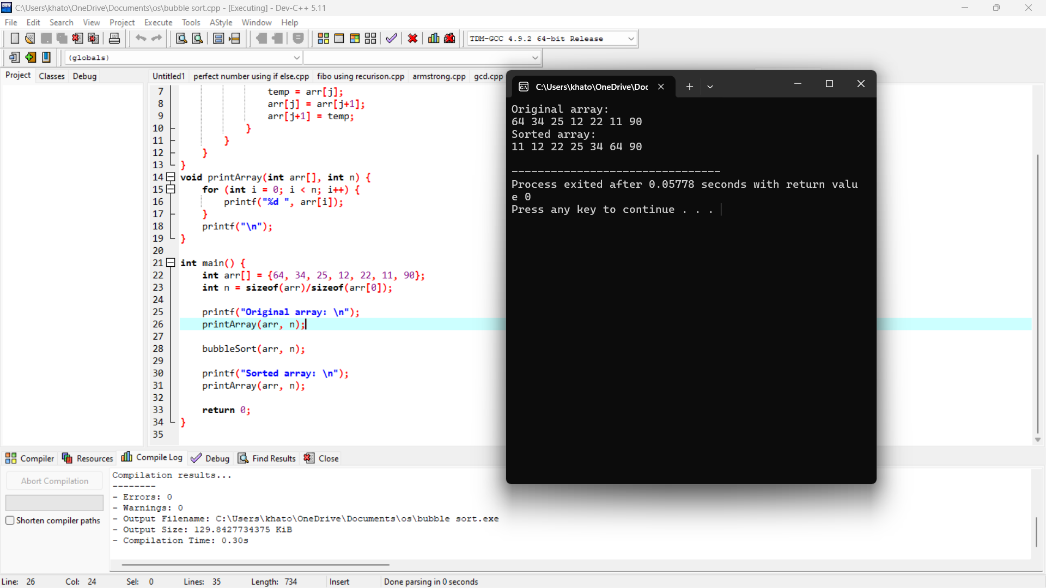

9. MATRIX MULTIPLICATION

#include <stdio.h>

#define MAX 10 // Maximum size of the matrix

void matrixMultiplication(int firstMatrix[MAX][MAX], int secondMatrix[MAX][MAX], int result[MAX][MAX], int row1, int col1, int row2, int col2) {

// Initialize the result matrix to zero

for (int i = 0; i < row1; i++) {

for (int j = 0; j < col2; j++) {

result[i][j] = 0;

}

}

// Multiply the two matrices

for (int i = 0; i < row1; i++) {

for (int j = 0; j < col2; j++) {

for (int k = 0; k < col1; k++) {

result[i][j] += firstMatrix[i][k] * secondMatrix[k][j];

}

}

}

}

int main() {

int firstMatrix[MAX][MAX], secondMatrix[MAX][MAX], result[MAX][MAX];

int row1, col1, row2, col2;

// Input dimensions of first matrix

printf("Enter rows and columns of first matrix: ");

scanf("%d %d", &row1, &col1);

// Input elements of first matrix

printf("Enter elements of first matrix:\n");

for (int i = 0; i < row1; i++) {

for (int j = 0; j < col1; j++) {

scanf("%d", &firstMatrix[i][j]);

}

}

// Input dimensions of second matrix

printf("Enter rows and columns of second matrix: ");

scanf("%d %d", &row2, &col2);

// Matrix multiplication condition: col1 should be equal to row2

if (col1 != row2) {

printf("Error! Matrix multiplication is not possible.\n");

return -1;

}

// Input elements of second matrix

printf("Enter elements of second matrix:\n");

for (int i = 0; i < row2; i++) {

for (int j = 0; j < col2; j++) {

scanf("%d", &secondMatrix[i][j]);

}

}

// Perform matrix multiplication

matrixMultiplication(firstMatrix, secondMatrix, result, row1, col1, row2, col2);

// Output the result matrix

printf("Resultant matrix:\n");

for (int i = 0; i < row1; i++) {

for (int j = 0; j < col2; j++) {

printf("%d ", result[i][j]);

}

printf("\n");

}

return 0;

}

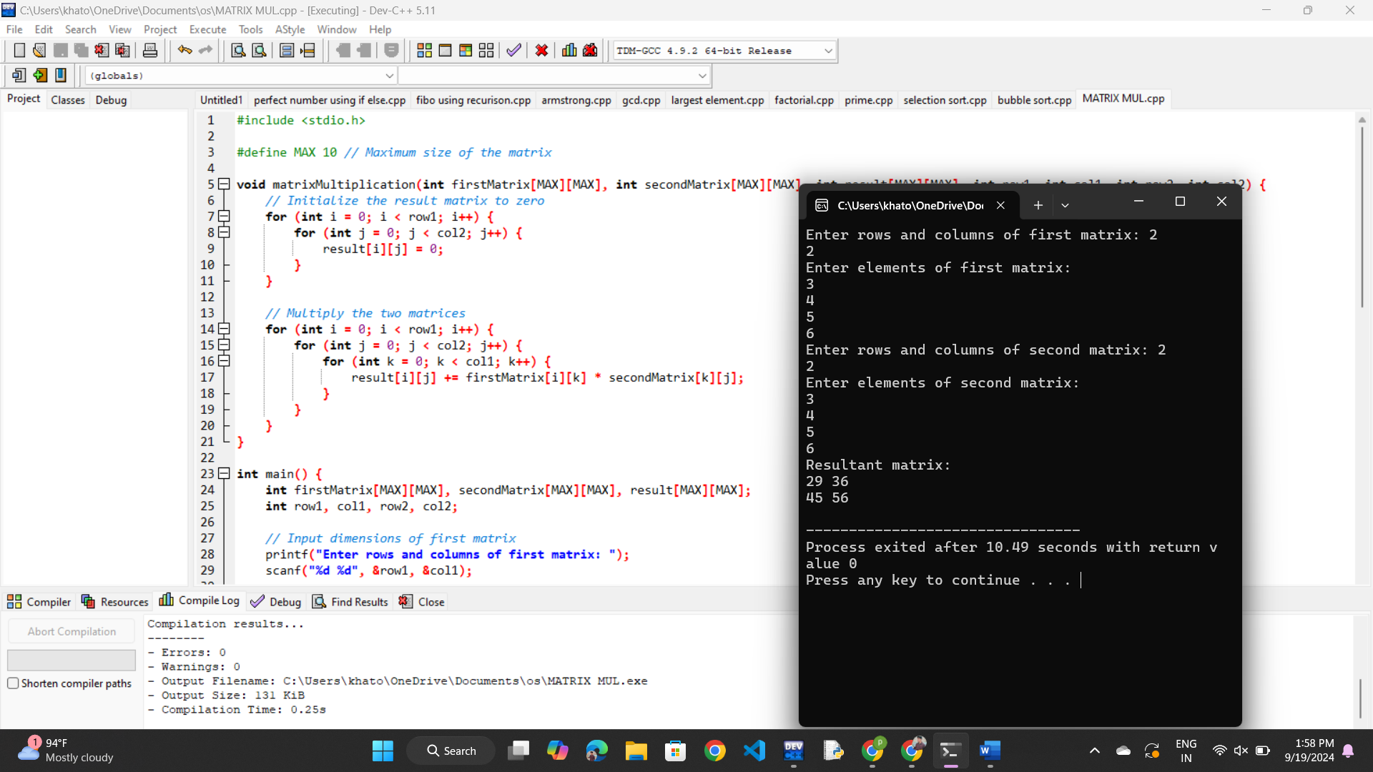

PALLINDROME

#include <stdio.h>

#include <string.h>

#include <ctype.h>

void checkPalindrome(char str[]) {

int len = strlen(str);

int start = 0;

int end = len - 1;

int isPalindrome = 1; // Assume the string is a palindrome

while (start < end) {

// Ignore non-alphanumeric characters and make it case-insensitive

while (start < end && !isalnum(str[start])) start++;

while (start < end && !isalnum(str[end])) end--;

if (tolower(str[start]) != tolower(str[end])) {

isPalindrome = 0; // Not a palindrome

break;

}

start++;

end--;

}

if (isPalindrome) {

printf("The string is a palindrome.\n");

} else {

printf("The string is not a palindrome.\n");

}

}

int main() {

char str[100];

printf("Enter a string: ");

fgets(str, sizeof(str), stdin); // Use fgets to allow spaces in the input

str[strcspn(str, "\n")] = '\0'; // Remove newline character if present

checkPalindrome(str);

return 0;

}

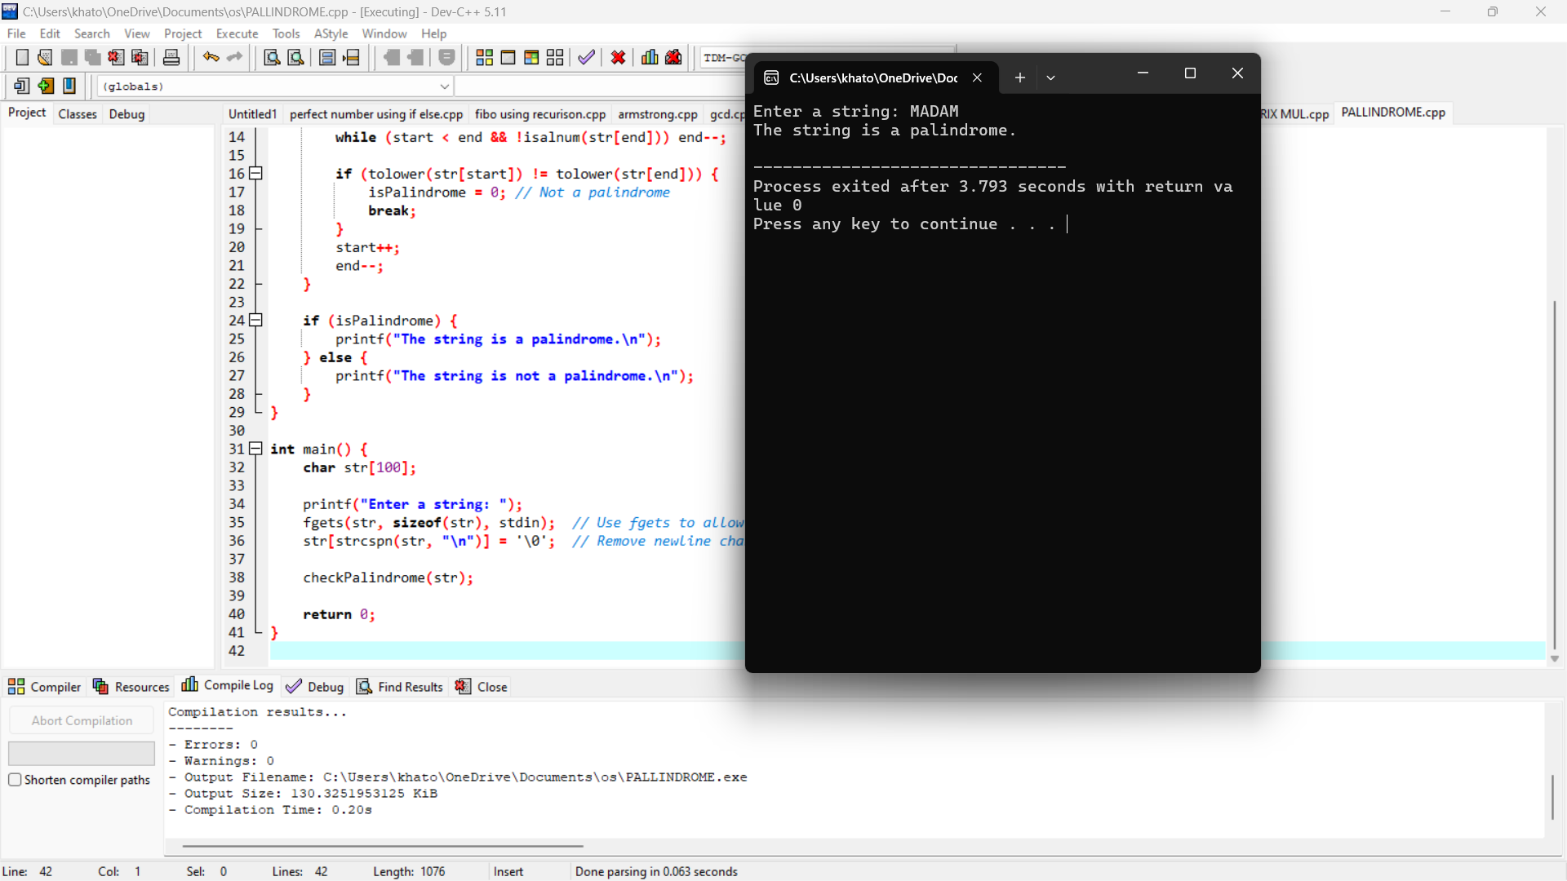

COPY THE STRING

#include <stdio.h>

#include <string.h>

int main() {

char source[100], destination[100];

// Input string from user

printf("Enter a string: ");

fgets(source, sizeof(source), stdin);

// Remove the trailing newline character that fgets adds

source[strcspn(source, "\n")] = 0;

// Copy the source string to destination

strcpy(destination, source);

// Output the copied string

printf("Copied string: %s\n", destination);

return 0;

}

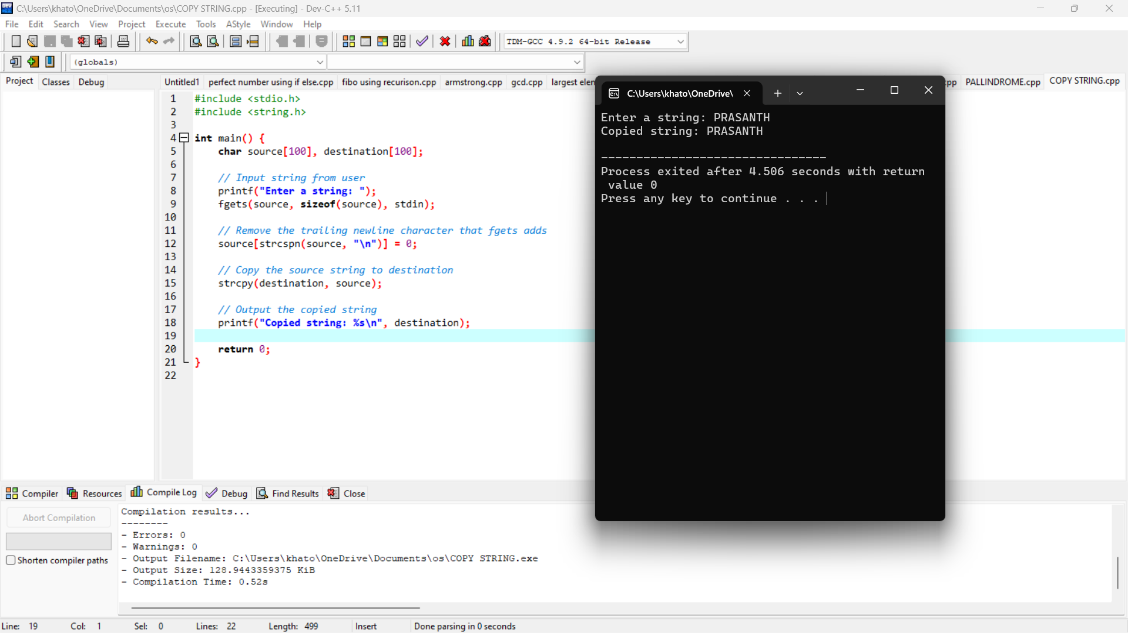

BINARY SEARCH

#include <stdio.h>

// Function to perform binary search

int binarySearch(int arr[], int size, int target) {

int left = 0;

int right = size - 1;

while (left <= right) {

int mid = left + (right - left) / 2; // Find the middle index

// Check if target is present at mid

if (arr[mid] == target)

return mid; // Target found

// If target is greater, ignore the left half

if (arr[mid] < target)

left = mid + 1;

// If target is smaller, ignore the right half

else

right = mid - 1;

}

return -1; // Target not found

}

int main() {

int arr[] = {2, 3, 4, 10, 40};

int size = sizeof(arr) / sizeof(arr[0]);

int target = 10;

// Perform binary search

int result = binarySearch(arr, size, target);

// Output result

if (result != -1)

printf("Element found at index %d\n", result);

else

printf("Element not found in the array\n");

return 0;

}

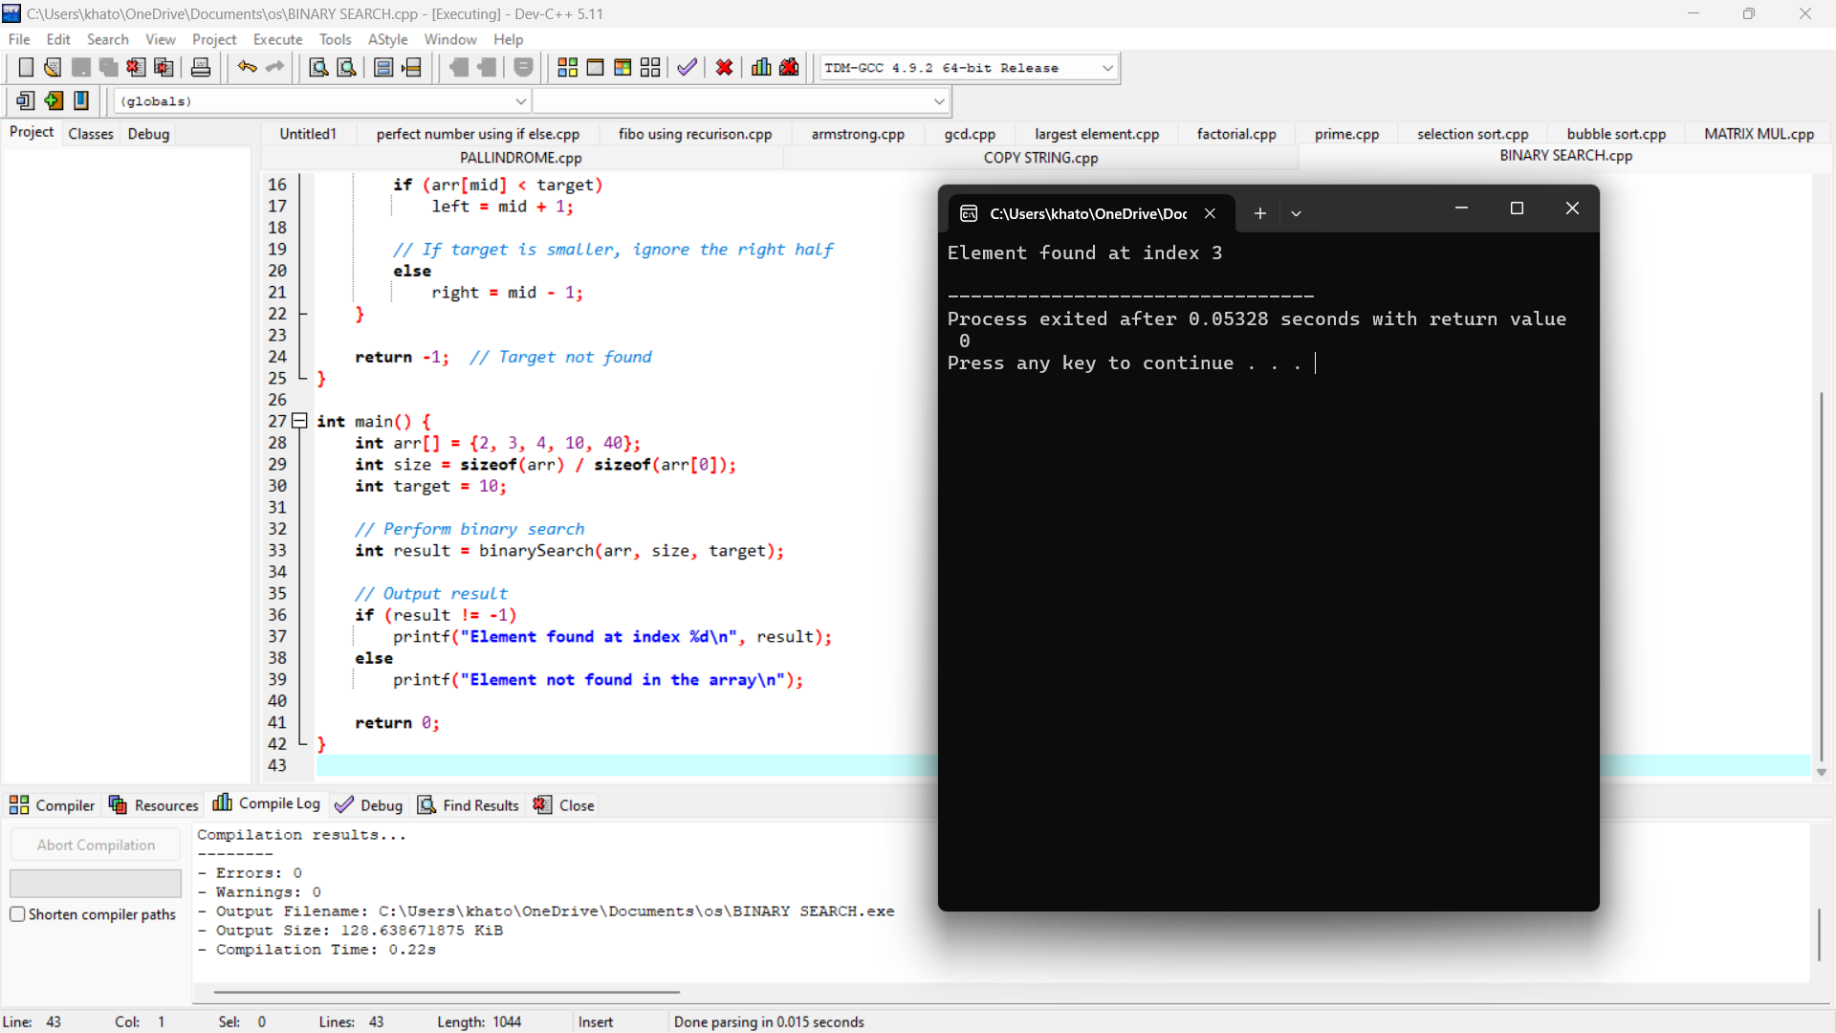

REVERSE STRING

#include <stdio.h>

#include <string.h>

void reverseString(char str[]) {

int n = strlen(str);

for (int i = 0; i < n / 2; i++) {

// Swap characters

char temp = str[i];

str[i] = str[n - i - 1];

str[n - i - 1] = temp;

}

}

int main() {

char str[100];

printf("Enter a string: ");

fgets(str, sizeof(str), stdin); // Read input string

str[strcspn(str, "\n")] = 0; // Remove newline character if present

reverseString(str); // Call function to reverse the string

printf("Reversed string: %s\n", str);

return 0;

}

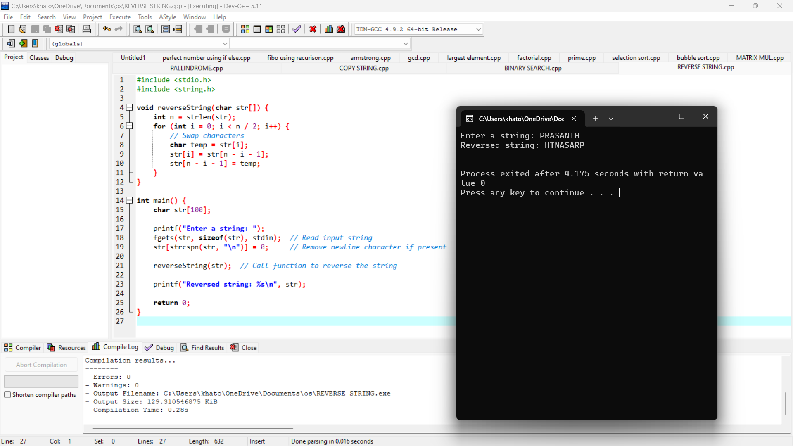

LENGTH OF STRING

#include <stdio.h>

#include <string.h> // For strlen

// Function to find length of string manually

int stringLength(char str[]) {

int length = 0;

while (str[length] != '\0') { // '\0' is the null character indicating the end of the string

length++;

}

return length;

}

int main() {

char str[100]; // Declaring a string of maximum size 100

// Input string from user

printf("Enter a string: ");

fgets(str, sizeof(str), stdin); // Using fgets to safely get input

// Remove newline character from fgets

str[strcspn(str, "\n")] = '\0';

// Using built-in function strlen

printf("Length of the string using strlen: %lu\n", strlen(str));

// Using manual method

printf("Length of the string manually: %d\n", stringLength(str));

return 0;

}

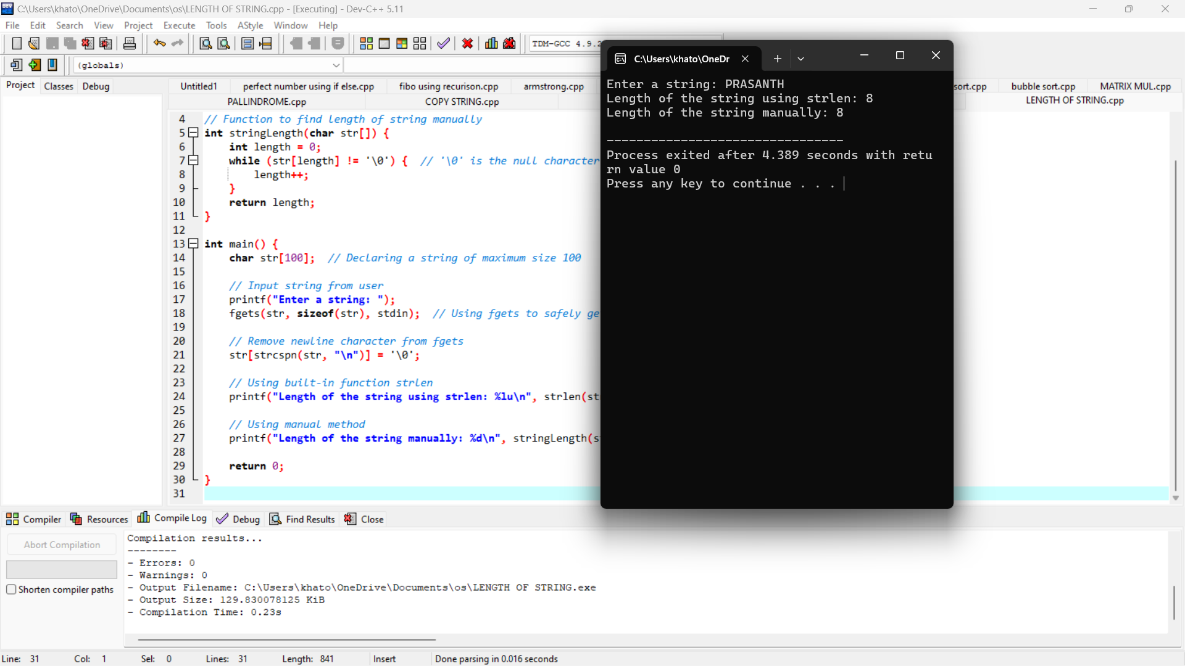

STRASSEN MATRIX

#include <stdio.h>

#include <stdlib.h>

// Function to add two matrices

void addMatrix(int n, int A[][n], int B[][n], int result[][n]) {

for (int i = 0; i < n; i++)

for (int j = 0; j < n; j++)

result[i][j] = A[i][j] + B[i][j];

}

// Function to subtract two matrices

void subtractMatrix(int n, int A[][n], int B[][n], int result[][n]) {

for (int i = 0; i < n; i++)

for (int j = 0; j < n; j++)

result[i][j] = A[i][j] - B[i][j];

}

// Strassen's matrix multiplication function

void strassenMultiply(int n, int A[][n], int B[][n], int C[][n]) {

// Base case: 2x2 matrix multiplication

if (n == 2) {

int P1 = (A[0][0] + A[1][1]) * (B[0][0] + B[1][1]);

int P2 = (A[1][0] + A[1][1]) * B[0][0];

int P3 = A[0][0] * (B[0][1] - B[1][1]);

int P4 = A[1][1] * (B[1][0] - B[0][0]);

int P5 = (A[0][0] + A[0][1]) * B[1][1];

int P6 = (A[1][0] - A[0][0]) * (B[0][0] + B[0][1]);

int P7 = (A[0][1] - A[1][1]) * (B[1][0] + B[1][1]);

C[0][0] = P1 + P4 - P5 + P7;

C[0][1] = P3 + P5;

C[1][0] = P2 + P4;

C[1][1] = P1 + P3 - P2 + P6;

return;

}

int newSize = n / 2;

int A11[newSize][newSize], A12[newSize][newSize], A21[newSize][newSize], A22[newSize][newSize];

int B11[newSize][newSize], B12[newSize][newSize], B21[newSize][newSize], B22[newSize][newSize];

int C11[newSize][newSize], C12[newSize][newSize], C21[newSize][newSize], C22[newSize][newSize];

int P1[newSize][newSize], P2[newSize][newSize], P3[newSize][newSize], P4[newSize][newSize], P5[newSize][newSize], P6[newSize][newSize], P7[newSize][newSize];

int temp1[newSize][newSize], temp2[newSize][newSize];

// Divide A and B matrices into 4 sub-matrices

for (int i = 0; i < newSize; i++) {

for (int j = 0; j < newSize; j++) {

A11[i][j] = A[i][j];

A12[i][j] = A[i][j + newSize];

A21[i][j] = A[i + newSize][j];

A22[i][j] = A[i + newSize][j + newSize];

B11[i][j] = B[i][j];

B12[i][j] = B[i][j + newSize];

B21[i][j] = B[i + newSize][j];

B22[i][j] = B[i + newSize][j + newSize];

}

}

// P1 = (A11 + A22) * (B11 + B22)

addMatrix(newSize, A11, A22, temp1);

addMatrix(newSize, B11, B22, temp2);

strassenMultiply(newSize, temp1, temp2, P1);

// P2 = (A21 + A22) * B11

addMatrix(newSize, A21, A22, temp1);

strassenMultiply(newSize, temp1, B11, P2);

// P3 = A11 * (B12 - B22)

subtractMatrix(newSize, B12, B22, temp1);

strassenMultiply(newSize, A11, temp1, P3);

// P4 = A22 * (B21 - B11)

subtractMatrix(newSize, B21, B11, temp1);

strassenMultiply(newSize, A22, temp1, P4);

// P5 = (A11 + A12) * B22

addMatrix(newSize, A11, A12, temp1);

strassenMultiply(newSize, temp1, B22, P5);

// P6 = (A21 - A11) * (B11 + B12)

subtractMatrix(newSize, A21, A11, temp1);

addMatrix(newSize, B11, B12, temp2);

strassenMultiply(newSize, temp1, temp2, P6);

// P7 = (A12 - A22) * (B21 + B22)

subtractMatrix(newSize, A12, A22, temp1);

addMatrix(newSize, B21, B22, temp2);

strassenMultiply(newSize, temp1, temp2, P7);

// C11 = P1 + P4 - P5 + P7

addMatrix(newSize, P1, P4, temp1);

subtractMatrix(newSize, temp1, P5, temp2);

addMatrix(newSize, temp2, P7, C11);

// C12 = P3 + P5

addMatrix(newSize, P3, P5, C12);

// C21 = P2 + P4

addMatrix(newSize, P2, P4, C21);

// C22 = P1 + P3 - P2 + P6

addMatrix(newSize, P1, P3, temp1);

subtractMatrix(newSize, temp1, P2, temp2);

addMatrix(newSize, temp2, P6, C22);

// Combine C11, C12, C21, C22 into result matrix C

for (int i = 0; i < newSize; i++) {

for (int j = 0; j < newSize; j++) {

C[i][j] = C11[i][j];

C[i][j + newSize] = C12[i][j];

C[i + newSize][j] = C21[i][j];

C[i + newSize][j + newSize] = C22[i][j];

}

}

}

int main() {

int n = 2; // Matrix size 2x2 (can be adjusted for larger sizes)

int A[2][2] = { {1, 2}, {3, 4} };

int B[2][2] = { {5, 6}, {7, 8} };

int C[2][2]; // Result matrix

strassenMultiply(n, A, B, C);

// Print the result

printf("Result of Strassen Matrix Multiplication:\n");

for (int i = 0; i < n; i++) {

for (int j = 0; j < n; j++) {

printf("%d ", C[i][j]);

}

printf("\n");

}

return 0;

}

MERGE SORT

#include <stdio.h>

// Function to merge two halves of the array

void merge(int arr[], int left, int mid, int right) {

int i, j, k;

int n1 = mid - left + 1;

int n2 = right - mid;

// Temporary arrays to hold the left and right halves

int leftArr[n1], rightArr[n2];

// Copy data to temporary arrays

for (i = 0; i < n1; i++)

leftArr[i] = arr[left + i];

for (j = 0; j < n2; j++)

rightArr[j] = arr[mid + 1 + j];

i = 0; // Initial index of the left array

j = 0; // Initial index of the right array

k = left; // Initial index of merged array

// Merge the two halves

while (i < n1 && j < n2) {

if (leftArr[i] <= rightArr[j]) {

arr[k] = leftArr[i];

i++;

} else {

arr[k] = rightArr[j];

j++;

}

k++;

}

// Copy the remaining elements of leftArr[], if any

while (i < n1) {

arr[k] = leftArr[i];

i++;

k++;

}

// Copy the remaining elements of rightArr[], if any

while (j < n2) {

arr[k] = rightArr[j];

j++;

k++;

}

}

// Function to implement Merge Sort

void mergeSort(int arr[], int left, int right) {

if (left < right) {

int mid = left + (right - left) / 2;

// Sort the first and second halves

mergeSort(arr, left, mid);

mergeSort(arr, mid + 1, right);

// Merge the sorted halves

merge(arr, left, mid, right);

}

}

// Function to print the array

void printArray(int arr[], int size) {

for (int i = 0; i < size; i++)

printf("%d ", arr[i]);

printf("\n");

}

// Main function

int main() {

int arr[] = {12, 11, 13, 5, 6, 7};

int arr_size = sizeof(arr) / sizeof(arr[0]);

printf("Given array: \n");

printArray(arr, arr_size);

mergeSort(arr, 0, arr_size - 1);

printf("Sorted array: \n");

printArray(arr, arr_size);

return 0;

}

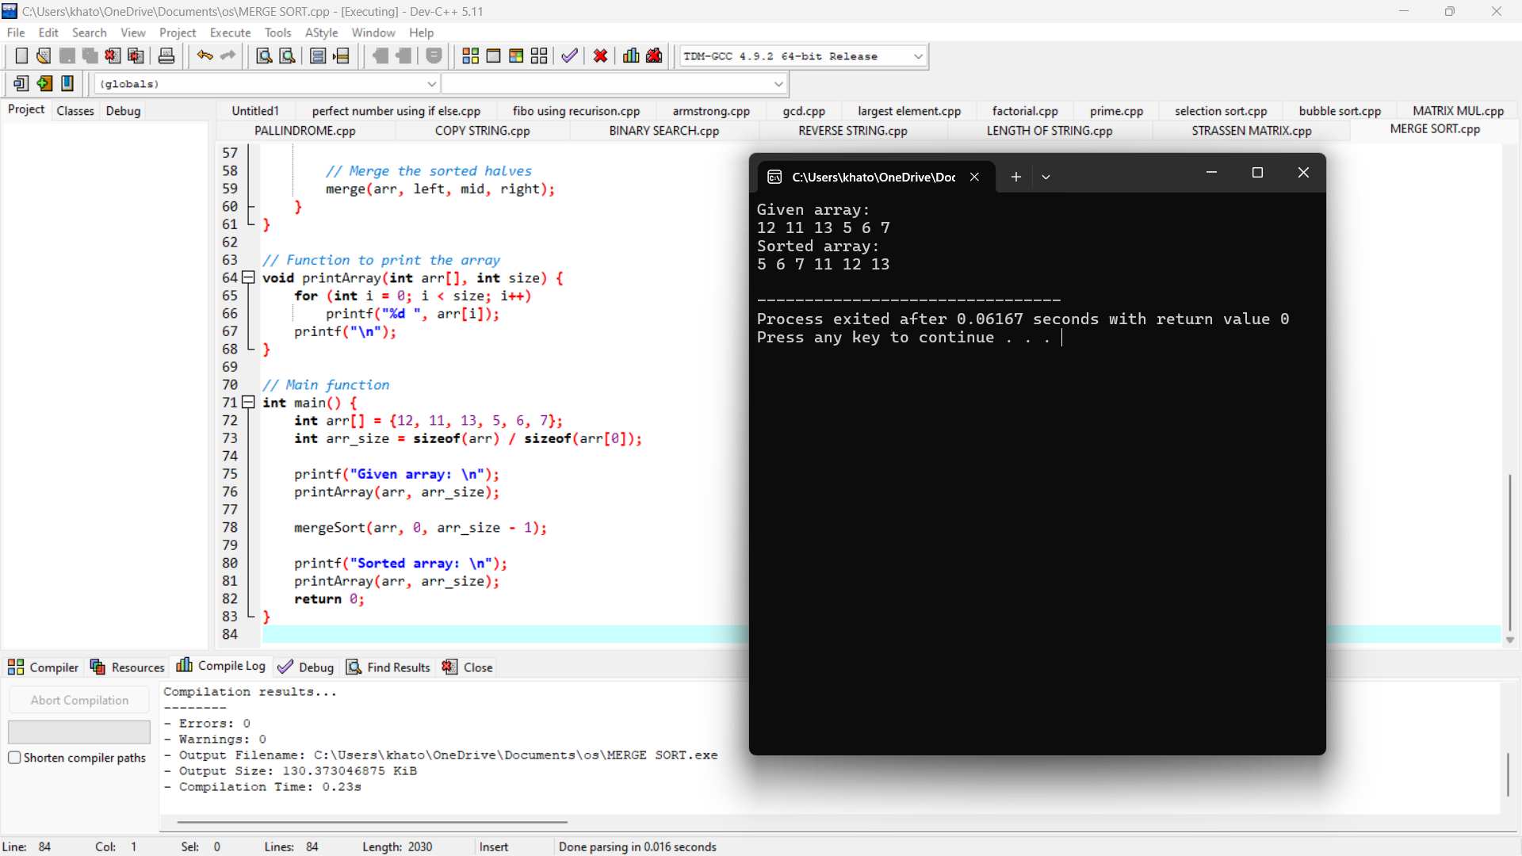

MAX AND MIN

#include <stdio.h>

int main() {

int n, i, max, min;

// Ask the user for the number of elements

printf("Enter the number of elements in the list: ");

scanf("%d", &n);

int arr[n]; // Declare an array of size n

// Input elements from the user

printf("Enter the elements:\n");

for (i = 0; i < n; i++) {

scanf("%d", &arr[i]);

}

// Initialize max and min to the first element of the array

max = min = arr[0];

// Loop through the array to find the max and min

for (i = 1; i < n; i++) {

if (arr[i] > max) {

max = arr[i];

}

if (arr[i] < min) {

min = arr[i];

}

}

// Output the results

printf("Maximum element: %d\n", max);

printf("Minimum element: %d\n", min);

return 0;

}

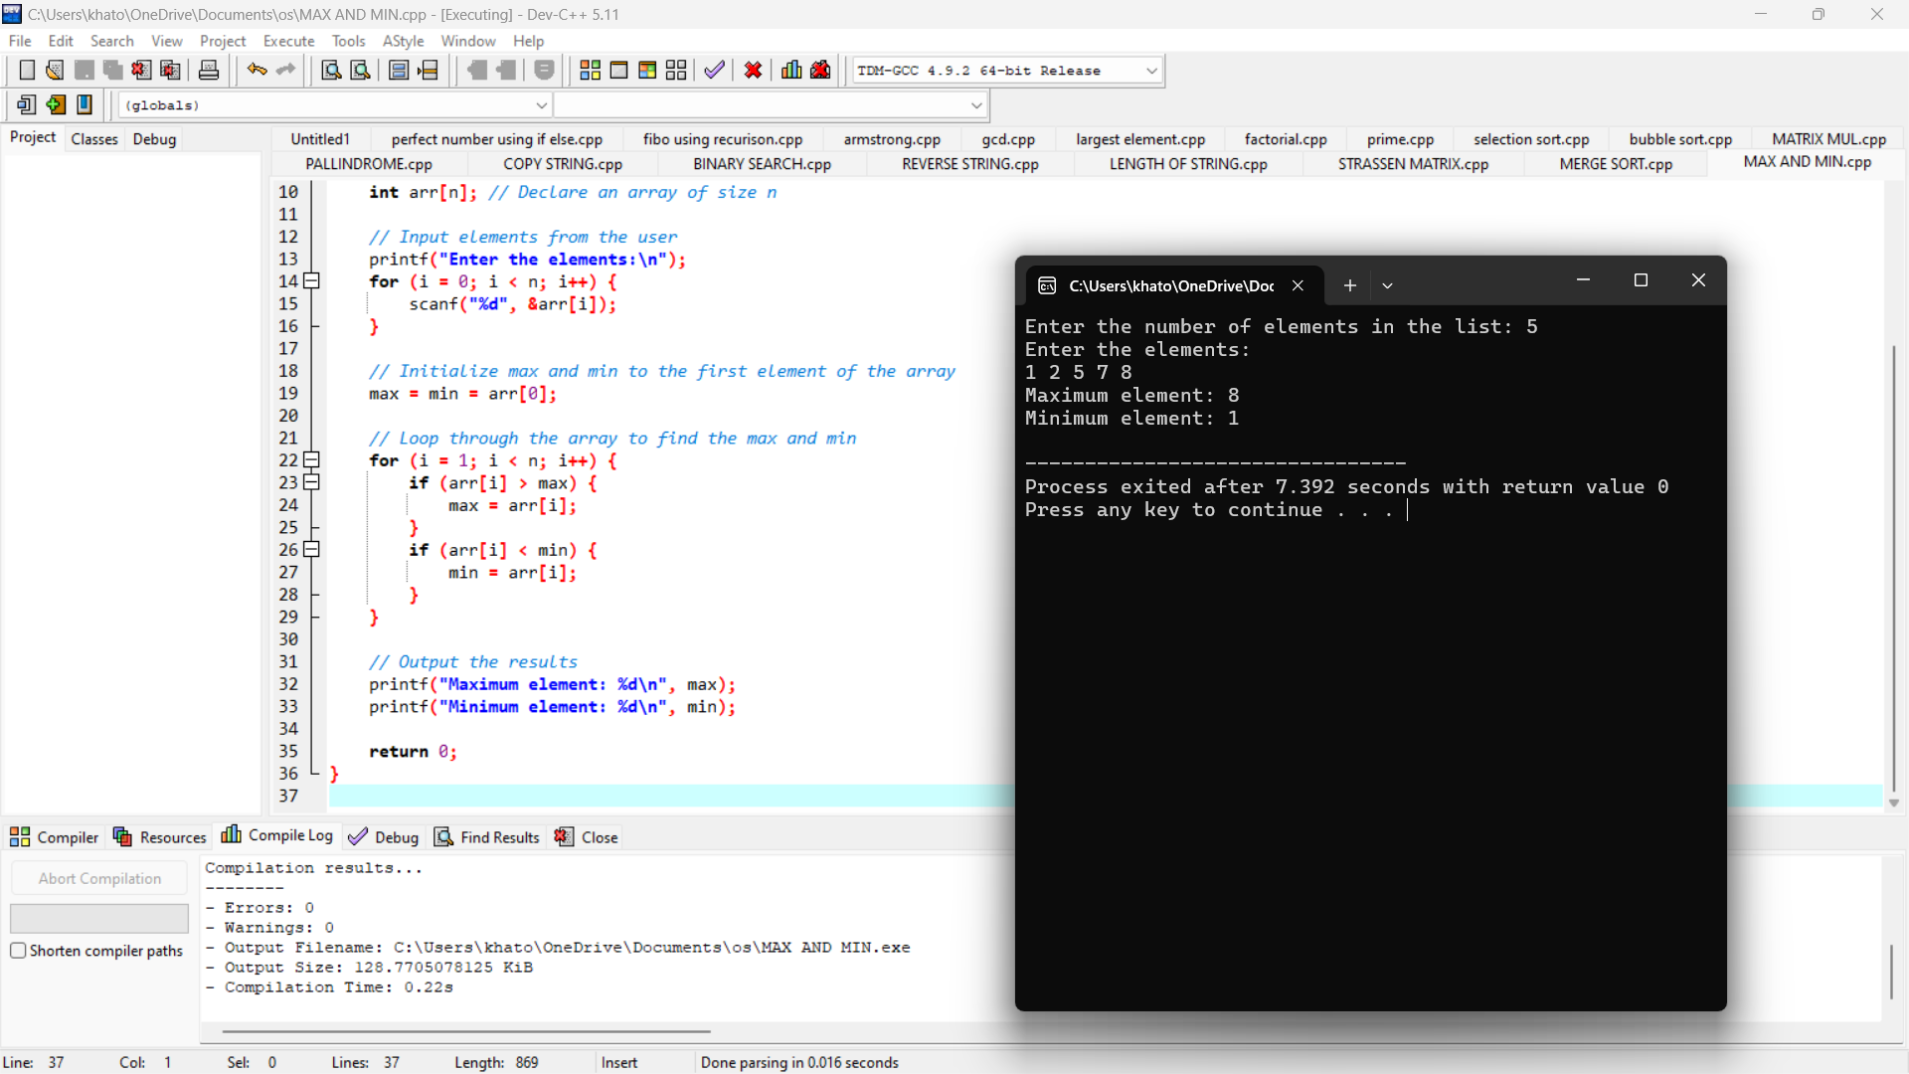

PRIME NUMBERS IN LIMIT

#include <stdio.h>

#include <stdbool.h>

// Function to check if a number is prime

bool isPrime(int num) {

if (num <= 1) return false;

if (num == 2) return true; // 2 is the only even prime number

if (num % 2 == 0) return false; // Eliminate even numbers

for (int i = 3; i * i <= num; i += 2) {

if (num % i == 0) return false;

}

return true;

}

int main() {

int numbers[] = {2, 3, 4, 5, 6, 7, 8, 9, 10, 11}; // Example list of numbers

int size = sizeof(numbers) / sizeof(numbers[0]); // Calculate size of the array

printf("Prime numbers in the list:\n");

for (int i = 0; i < size; i++) {

if (isPrime(numbers[i])) {

printf("%d\n", numbers[i]);

}

}

return 0;

}

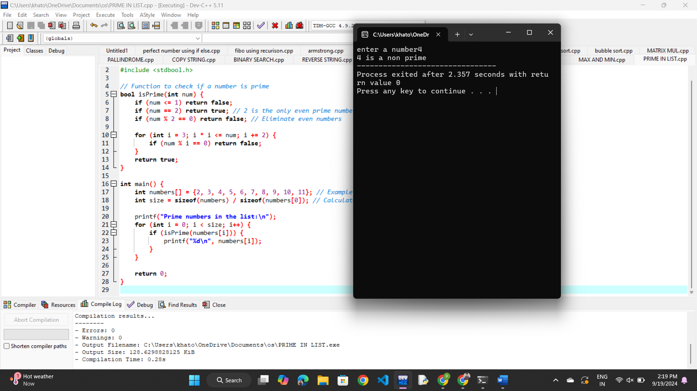

PRIME NUMBERS UPTO

#include <stdio.h>

#include <stdbool.h>

// Function to check if a number is prime

bool isPrime(int num) {

if (num <= 1) return false;

if (num == 2) return true;

if (num % 2 == 0) return false;

for (int i = 3; i * i <= num; i += 2) {

if (num % i == 0) return false;

}

return true;

}

int main() {

int limit;

// Get the limit from the user

printf("Enter the limit: ");

scanf("%d", &limit);

printf("Prime numbers up to %d are:\n", limit);

// Find and print all prime numbers up to the limit

for (int num = 2; num <= limit; num++) {

if (isPrime(num)) {

printf("%d ", num);

}

}

printf("\n");

return 0;

}

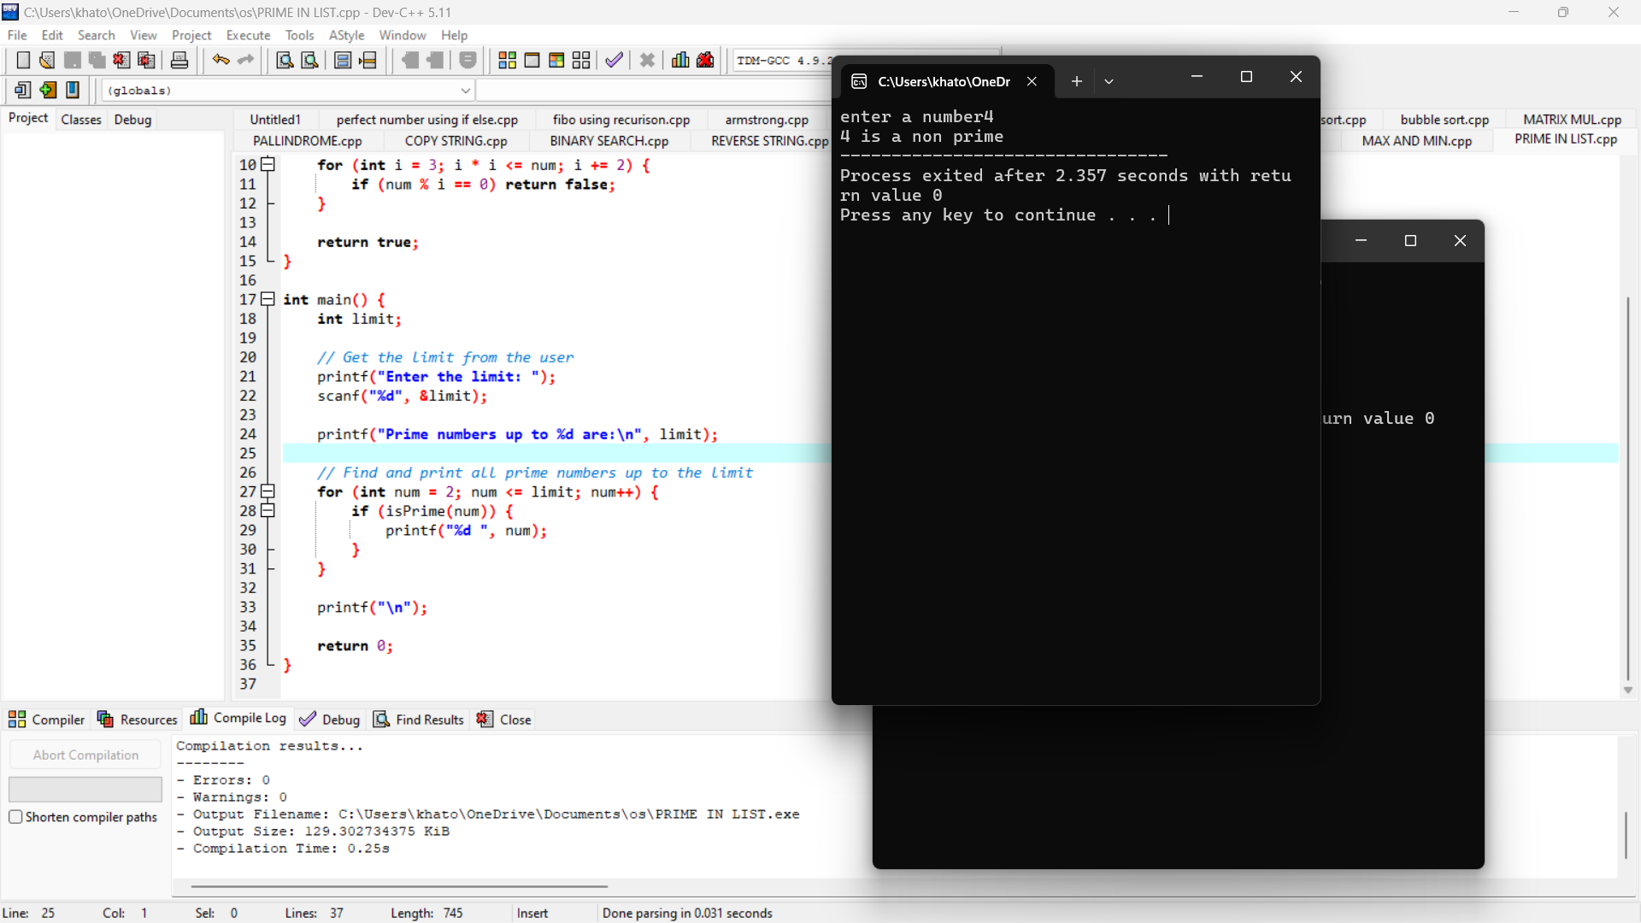

KNAPSACK USING GREEDY TECHNIQUE

#include <stdio.h>

// Structure to represent an item

typedef struct {

int weight;

int value;

double ratio;

} Item;

// Function to sort items based on their value-to-weight ratio in descending order

void sortItems(Item items[], int n) {

Item temp;

for (int i = 0; i < n-1; i++) {

for (int j = 0; j < n-i-1; j++) {

if (items[j].ratio < items[j+1].ratio) {

// Swap items[j] and items[j+1]

temp = items[j];

items[j] = items[j+1];

items[j+1] = temp;

}

}

}

}

// Function to solve the fractional knapsack problem

double fractionalKnapsack(Item items[], int n, int capacity) {

sortItems(items, n);

double totalValue = 0.0;

int remainingCapacity = capacity;

for (int i = 0; i < n; i++) {

if (items[i].weight <= remainingCapacity) {

// Take the whole item

remainingCapacity -= items[i].weight;

totalValue += items[i].value;

} else {

// Take the fraction of the item

totalValue += items[i].value * ((double)remainingCapacity / items[i].weight);

break;

}

}

return totalValue;

}

int main() {

int n, capacity;

// Input number of items and knapsack capacity

printf("Enter the number of items: ");

scanf("%d", &n);

printf("Enter the capacity of the knapsack: ");

scanf("%d", &capacity);

Item items[n];

// Input weight and value of each item

for (int i = 0; i < n; i++) {

printf("Enter weight and value for item %d: ", i + 1);

scanf("%d %d", &items[i].weight, &items[i].value);

items[i].ratio = (double)items[i].value / items[i].weight;

}

double maxValue = fractionalKnapsack(items, n, capacity);

printf("Maximum value in the knapsack = %.2f\n", maxValue);

return 0;

}

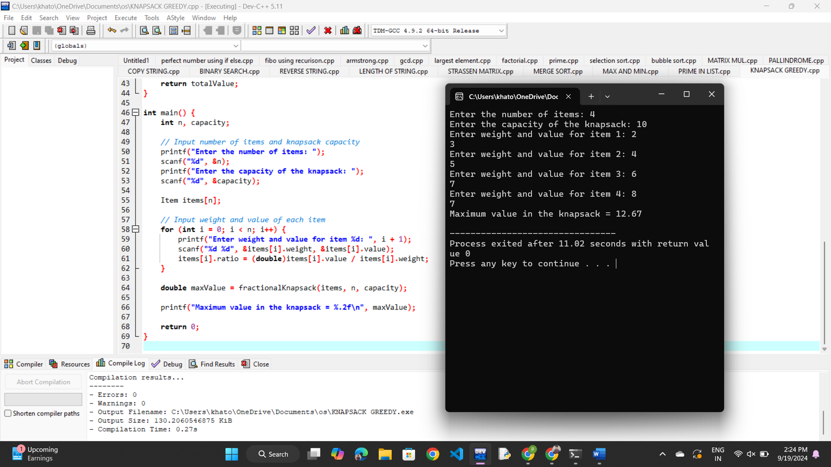

MST USING GREEDY

#include <stdio.h>

#include <stdlib.h>

// Define the maximum number of vertices

#define MAX_VERTICES 100

#define INF 999999

// Structure to represent an edge

typedef struct {

int src, dest, weight;

} Edge;

// Structure to represent a subset for Union-Find

typedef struct {

int parent, rank;

} Subset;

// Function prototypes

int find(Subset subsets[], int i);

void unionSets(Subset subsets[], int x, int y);

int compare(const void *a, const void *b);

// Kruskal's algorithm to find MST

void kruskal(Edge edges[], int V, int E) {

Edge result[V]; // To store the resulting MST

Subset subsets[V]; // To represent the Union-Find structure

int e = 0; // Count of edges in MST

int i = 0; // Initial index of sorted edges

// Initialize subsets

for (int v = 0; v < V; ++v) {

subsets[v].parent = v;

subsets[v].rank = 0;

}

// Sort all edges by weight

qsort(edges, E, sizeof(edges[0]), compare);

// Process each edge in sorted order

while (e < V - 1 && i < E) {

Edge next_edge = edges[i++];

int x = find(subsets, next_edge.src);

int y = find(subsets, next_edge.dest);

// If including this edge does not cause a cycle

if (x != y) {

result[e++] = next_edge;

unionSets(subsets, x, y);

}

}

// Print the MST

printf("Edges in the MST:\n");

int mst_weight = 0;

for (i = 0; i < e; ++i) {

printf("%d -- %d == %d\n", result[i].src, result[i].dest, result[i].weight);

mst_weight += result[i].weight;

}

printf("Weight of MST: %d\n", mst_weight);

}

// Find function for Union-Find

int find(Subset subsets[], int i) {

if (subsets[i].parent != i)

subsets[i].parent = find(subsets, subsets[i].parent);

return subsets[i].parent;

}

// Union function for Union-Find

void unionSets(Subset subsets[], int x, int y) {

int xroot = find(subsets, x);

int yroot = find(subsets, y);

if (subsets[xroot].rank < subsets[yroot].rank)

subsets[xroot].parent = yroot;

else if (subsets[xroot].rank > subsets[yroot].rank)

subsets[yroot].parent = xroot;

else {

subsets[yroot].parent = xroot;

subsets[xroot].rank++;

}

}

// Comparison function for sorting edges

int compare(const void *a, const void *b) {

return ((Edge *)a)->weight - ((Edge *)b)->weight;

}

// Main function

int main() {

int V, E;

printf("Enter number of vertices and edges: ");

scanf("%d %d", &V, &E);

Edge edges[E];

printf("Enter the edges in format src dest weight:\n");

for (int i = 0; i < E; i++) {

scanf("%d %d %d", &edges[i].src, &edges[i].dest, &edges[i].weight);

}

kruskal(edges, V, E);

return 0;

}

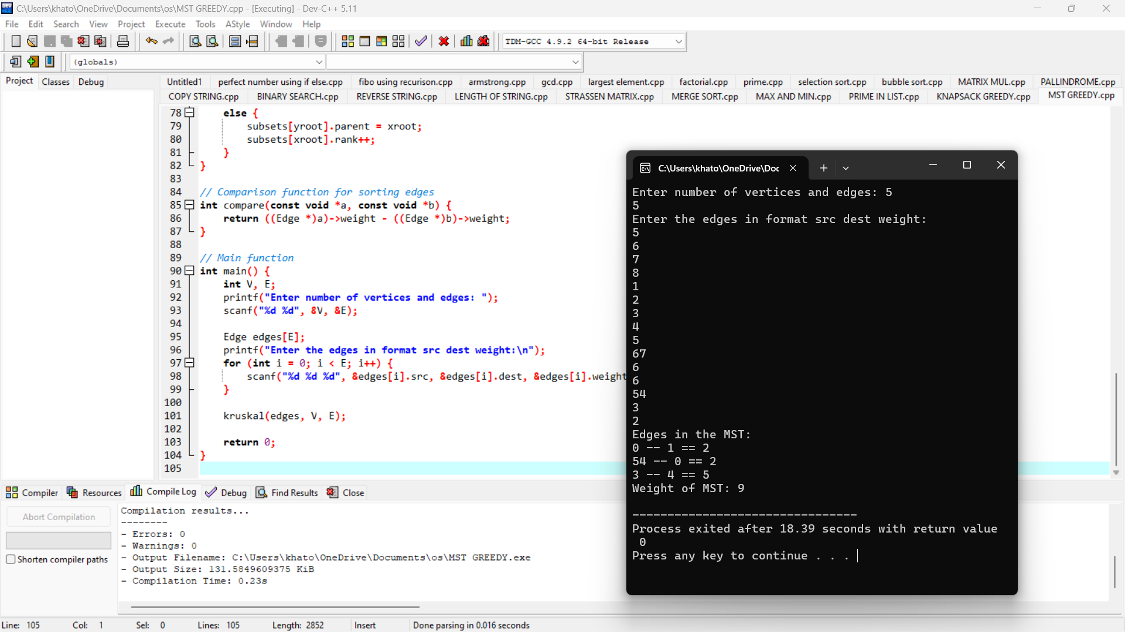

**OPTIMAL BINARY SEARCH TREE**

#include <stdio.h>

#include <limits.h>

// Function prototypes

void printOptimalBST(int i, int j, int s[][j+1], int keys[], int n);

void optimalBST(int keys[], int freq[], int n);

int main() {

int keys[] = {10, 12, 20}; // Keys in the BST

int freq[] = {34, 8, 50}; // Frequencies of the keys

int n = sizeof(keys)/sizeof(keys[0]);

optimalBST(keys, freq, n);

return 0;

}

// Function to print the optimal BST

void printOptimalBST(int i, int j, int s[][j+1], int keys[], int n) {

if (i <= j) {

printf("Key %d (root) with keys in range [%d-%d]\n", keys[s[i][j]], i, j);

printOptimalBST(i, s[i][j] - 1, s, keys, n);

printOptimalBST(s[i][j] + 1, j, s, keys, n);

}

}

// Function to construct and print the optimal BST

void optimalBST(int keys[], int freq[], int n) {

int i, j, len, r;

int cost[n][n], s[n][n];

// Initialize cost and s tables

for (i = 0; i < n; i++) {

cost[i][i] = freq[i];

s[i][i] = i;

for (j = i + 1; j < n; j++) {

cost[i][j] = INT_MAX;

}

}

// Build the cost and s tables

for (len = 2; len <= n; len++) {

for (i = 0; i <= n - len; i++) {

j = i + len - 1;

int sum = 0;

for (r = i; r <= j; r++) {

sum += freq[r];

}

for (r = i; r <= j; r++) {

int c = (r > i ? cost[i][r - 1] : 0) + (r < j ? cost[r + 1][j] : 0) + sum;

if (c < cost[i][j]) {

cost[i][j] = c;

s[i][j] = r;

}

}

}

}

// Print the cost of the optimal BST

printf("Cost of Optimal BST: %d\n", cost[0][n - 1]);

// Print the optimal BST structure

printf("Optimal BST structure:\n");

printOptimalBST(0, n - 1, s, keys, n);

}

**BINOMIAL COEFFECIENT**

#include <stdio.h>

// Function to calculate factorial of a number

unsigned long long factorial(int n) {

if (n == 0 || n == 1) return 1;

unsigned long long fact = 1;

for (int i = 2; i <= n; i++) {

fact *= i;

}

return fact;

}

// Function to calculate binomial coefficient

unsigned long long binomialCoefficient(int n, int k) {

if (k > n - k) k = n - k; // Take advantage of symmetry

unsigned long long numerator = 1;

unsigned long long denominator = 1;

for (int i = 0; i < k; i++) {

numerator *= (n - i);

denominator *= (i + 1);

}

return numerator / denominator;

}

int main() {

int n, k;

printf("Enter values for n and k: ");

scanf("%d %d", &n, &k);

if (k > n || n < 0 || k < 0) {

printf("Invalid values. Ensure 0 <= k <= n and n >= 0.\n");

return 1;

}

printf("Binomial Coefficient C(%d, %d) = %llu\n", n, k, binomialCoefficient(n, k));

return 0;

}

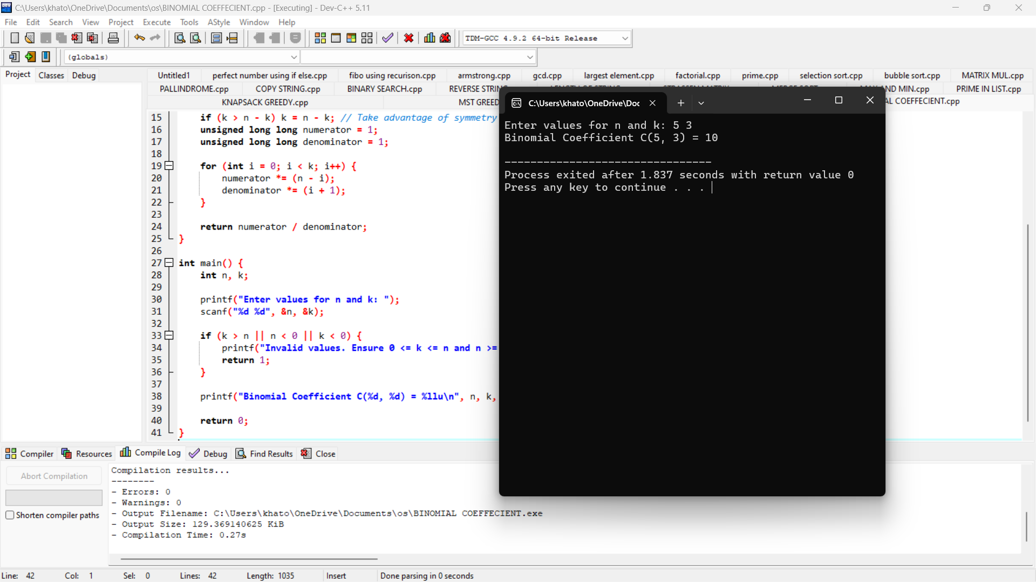

**REVERSE A NUMBER**

#include <stdio.h>

int main() {

int num, reversed = 0, remainder;

// Input the number from the user

printf("Enter an integer: ");

scanf("%d", &num);

// Reverse the number

while (num != 0) {

remainder = num % 10; // Get the last digit

reversed = reversed * 10 + remainder; // Append the digit to reversed

num /= 10; // Remove the last digit

}

// Output the reversed number

printf("Reversed number: %d\n", reversed);

return 0;

}

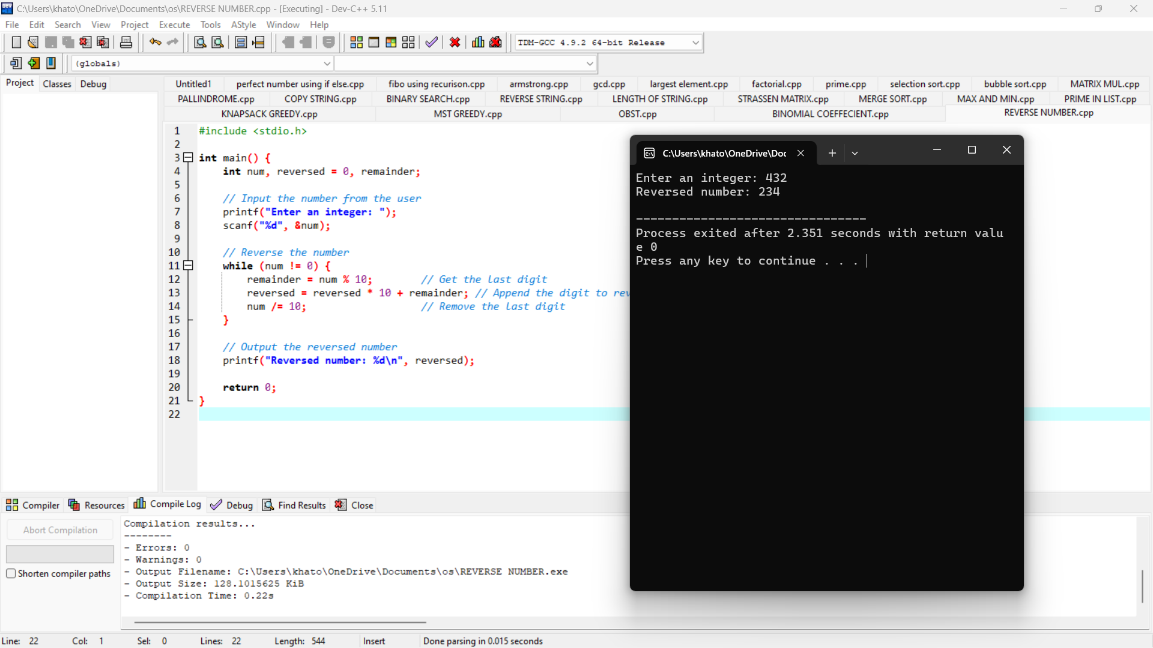

**PERFECT NUMBER**

#include <stdio.h>

int main() {

int num, i, sum = 0;

// Input number from user

printf("Enter a positive integer: ");

scanf("%d", &num);

// Check if the number is positive

if (num <= 0) {

printf("The number must be a positive integer.\n");

return 1; // Exit the program with error code

}

// Find sum of proper divisors

for (i = 1; i <= num / 2; ++i) {

if (num % i == 0) {

sum += i;

}

}

// Check if the number is a perfect number

if (sum == num) {

printf("%d is a perfect number.\n", num);

} else {

printf("%d is not a perfect number.\n", num);

}

return 0; // Exit the program successfully

}

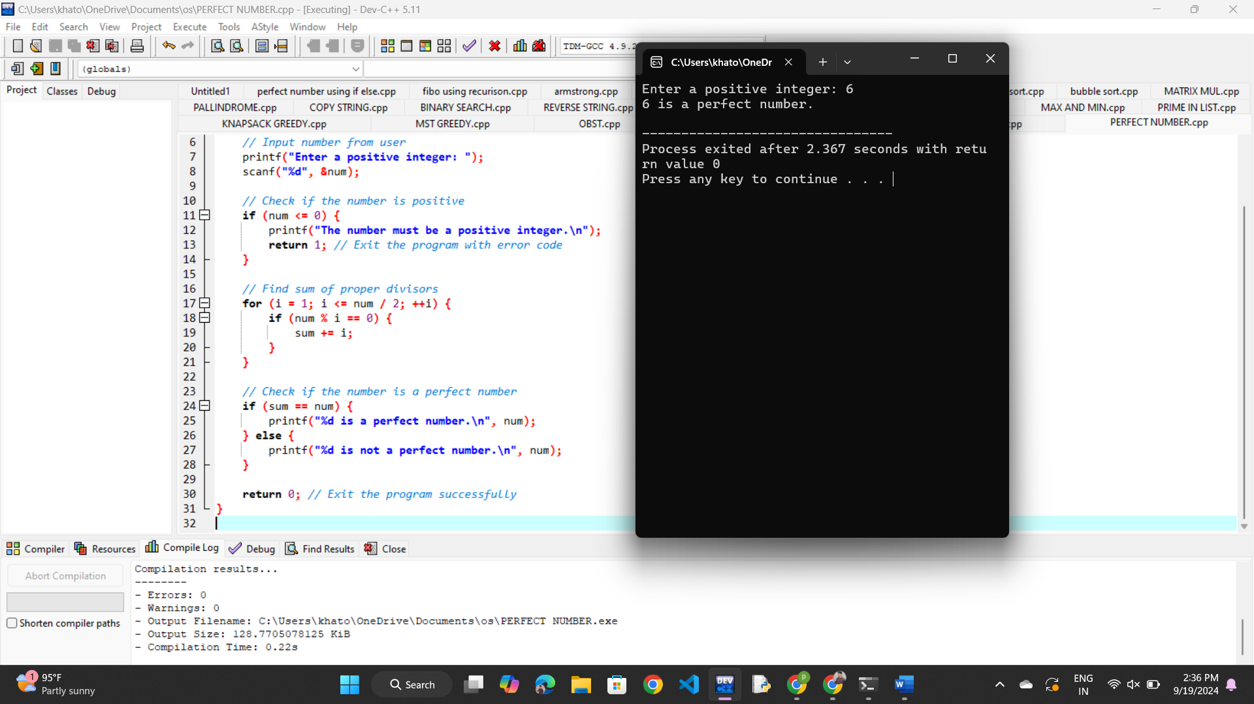

**TSP USING DYNAMIC PROGRAMMING**

#include <stdio.h>

#include <limits.h>

#define MAX 16

#define INF 1000000

int dist[MAX][MAX];

int dp[1 << MAX][MAX];

// Function to find the minimum of two numbers

int min(int a, int b) {

return (a < b) ? a : b;

}

// Recursive function to solve TSP

int tsp(int mask, int pos, int n) {

// If all cities have been visited, return to the starting point

if (mask == (1 << n) - 1) {

return dist[pos][0];

}

// If this state has already been computed

if (dp[mask][pos] != -1) {

return dp[mask][pos];

}

int answer = INF;

// Try to visit all unvisited cities

for (int city = 0; city < n; city++) {

// If city is not visited

if ((mask & (1 << city)) == 0) {

int newAnswer = dist[pos][city] + tsp(mask | (1 << city), city, n);

answer = min(answer, newAnswer);

}

}

// Store and return the result

dp[mask][pos] = answer;

return answer;

}

int main() {

int n;

printf("Enter the number of cities: ");

scanf("%d", &n);

printf("Enter the distance matrix:\n");

for (int i = 0; i < n; i++) {

for (int j = 0; j < n; j++) {

scanf("%d", &dist[i][j]);

}

}

// Initialize the dp table

for (int i = 0; i < (1 << n); i++) {

for (int j = 0; j < n; j++) {

dp[i][j] = -1;

}

}

// Start from city 0, with only city 0 visited

int result = tsp(1, 0, n);

printf("The minimum cost is: %d\n", result);

return 0;

}

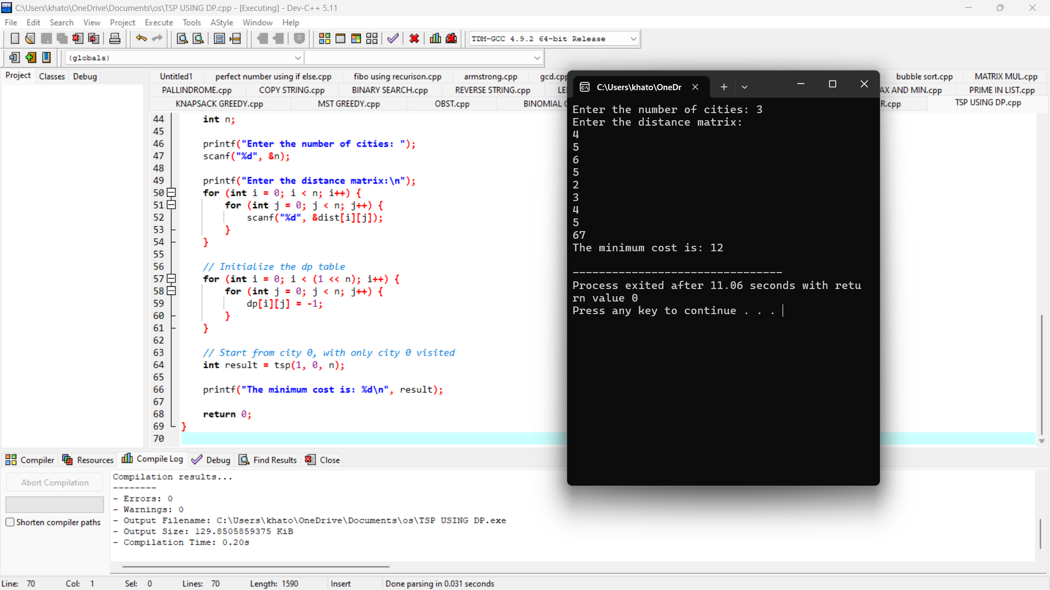

**PATTERN**

#include <stdio.h>

int main() {

int height, i, j;

// Ask the user for the height of the pyramid

printf("Enter the height of the pyramid: ");

scanf("%d", &height);

// Loop to print each level of the pyramid

for (i = 1; i <= height; i++) {

// Print spaces for the left side of the pyramid

for (j = i; j < height; j++) {

printf(" ");

}

// Print stars for the pyramid body

for (j = 1; j <= (2 * i - 1); j++) {

printf("*");

}

// Move to the next line after each level

printf("\n");

}

return 0;

}

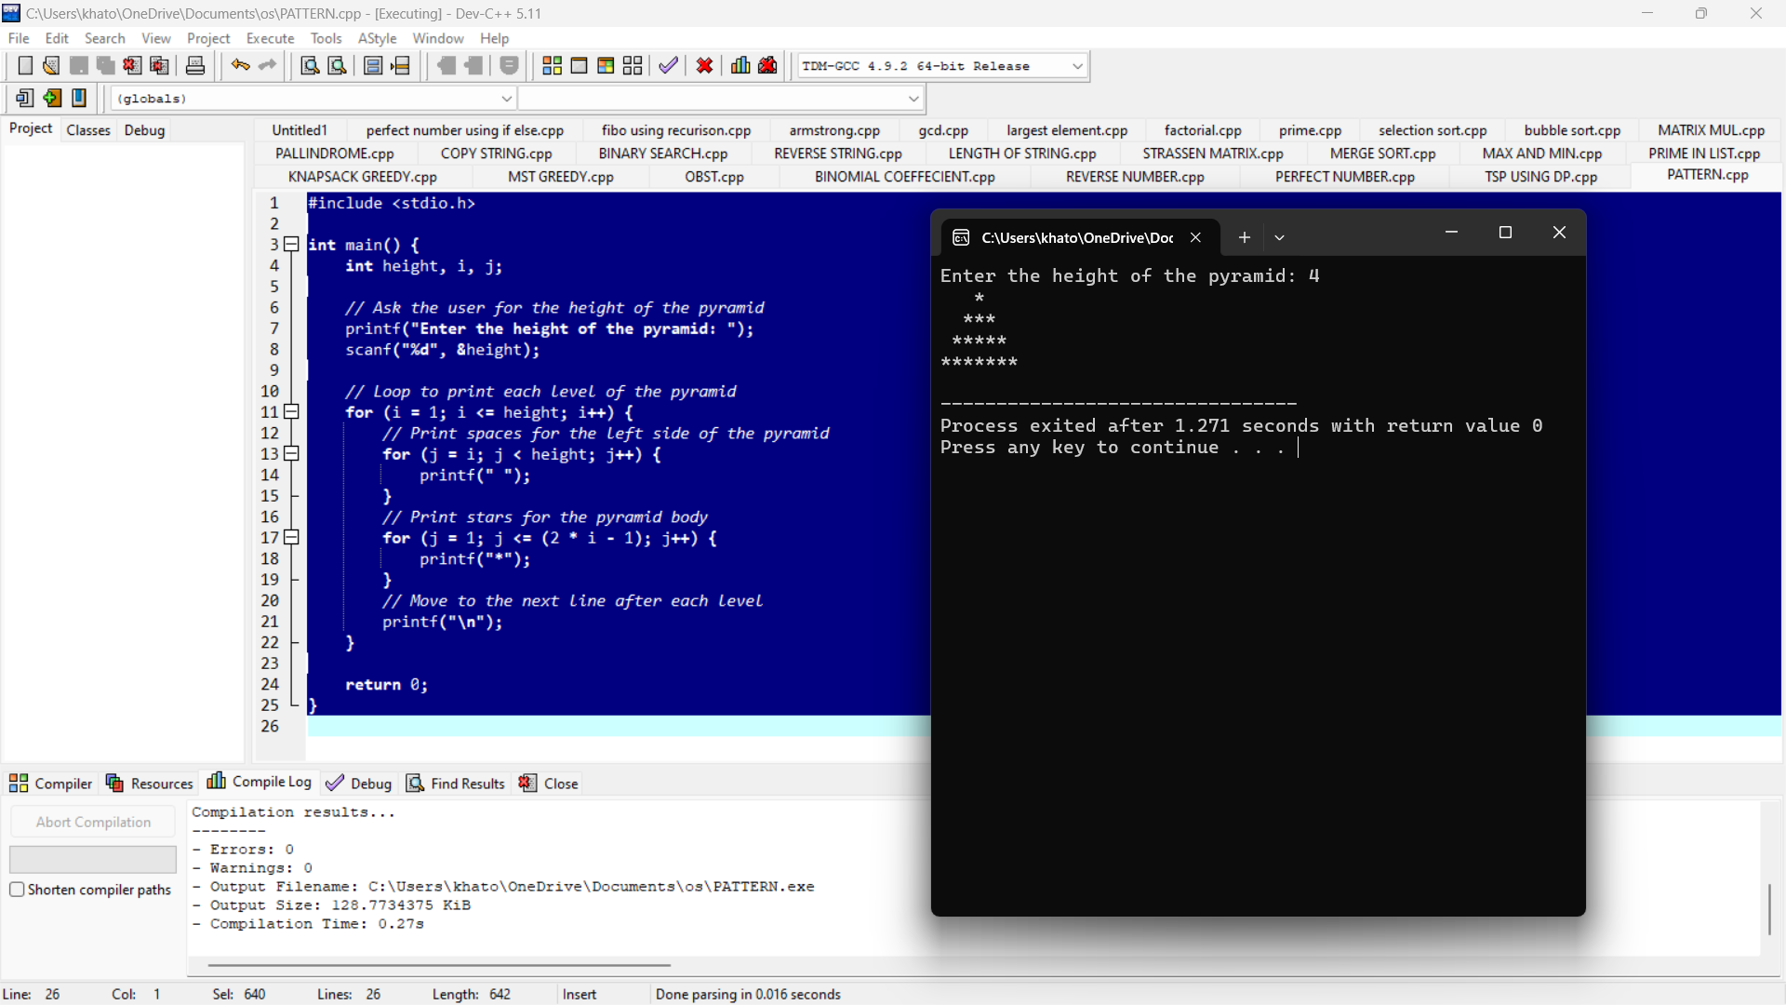

**FLOYD ALGORITHM**

#include <stdio.h>

#define INF 99999 // A large value to represent infinity

#define V 4 // Number of vertices in the graph

// Function to print the solution matrix

void printSolution(int dist[][V]) {

printf("The following matrix shows the shortest distances between every pair of vertices:\n");

for (int i = 0; i < V; i++) {

for (int j = 0; j < V; j++) {

if (dist[i][j] == INF)

printf("%7s", "INF");

else

printf("%7d", dist[i][j]);

}

printf("\n");

}

}

// Floyd-Warshall algorithm to find the shortest path between all pairs of vertices

void floydWarshall(int graph[][V]) {

int dist[V][V], i, j, k;

// Initialize the solution matrix the same as the input graph matrix

for (i = 0; i < V; i++)

for (j = 0; j < V; j++)

dist[i][j] = graph[i][j];

// Adding vertices individually to the set of intermediate vertices

for (k = 0; k < V; k++) {

for (i = 0; i < V; i++) {

for (j = 0; j < V; j++) {

// Update dist[i][j] if a shorter path exists through vertex k

if (dist[i][k] + dist[k][j] < dist[i][j])

dist[i][j] = dist[i][k] + dist[k][j];

}

}

}

// Print the final shortest distance matrix

printSolution(dist);

}

int main() {

// Input graph represented by an adjacency matrix

int graph[V][V] = { {0, 3, INF, 7},

{8, 0, 2, INF},

{5, INF, 0, 1},

{2, INF, INF, 0} };

// Execute the Floyd-Warshall algorithm

floydWarshall(graph);

return 0;

}

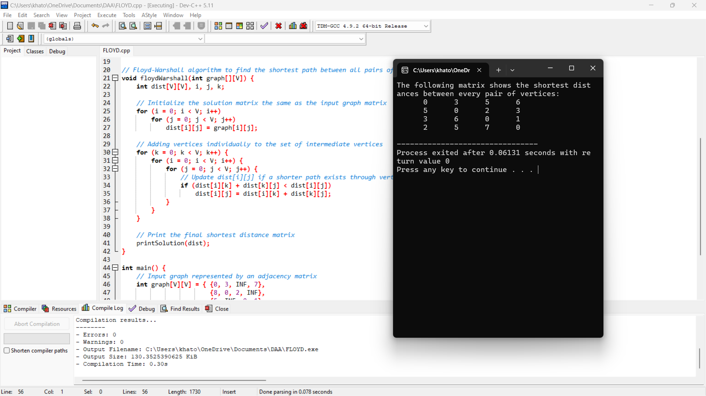

**PASCAL TRIANGLE**

#include <stdio.h>

// Function to calculate factorial of a number

long long factorial(int n) {

long long fact = 1;

for (int i = 1; i <= n; i++) {

fact *= i;

}

return fact;

}

// Function to print Pascal's triangle

void printPascalsTriangle(int rows) {

for (int i = 0; i < rows; i++) {

// Print spaces for formatting

for (int j = 0; j < rows - i - 1; j++) {

printf(" ");

}

// Calculate and print values of each row

for (int j = 0; j <= i; j++) {

long long value = factorial(i) / (factorial(j) * factorial(i - j));

printf("%4lld ", value);

}

printf("\n");

}

}

int main() {

int rows;

printf("Enter the number of rows for Pascal's triangle: ");

scanf("%d", &rows);

printPascalsTriangle(rows);

return 0;

}

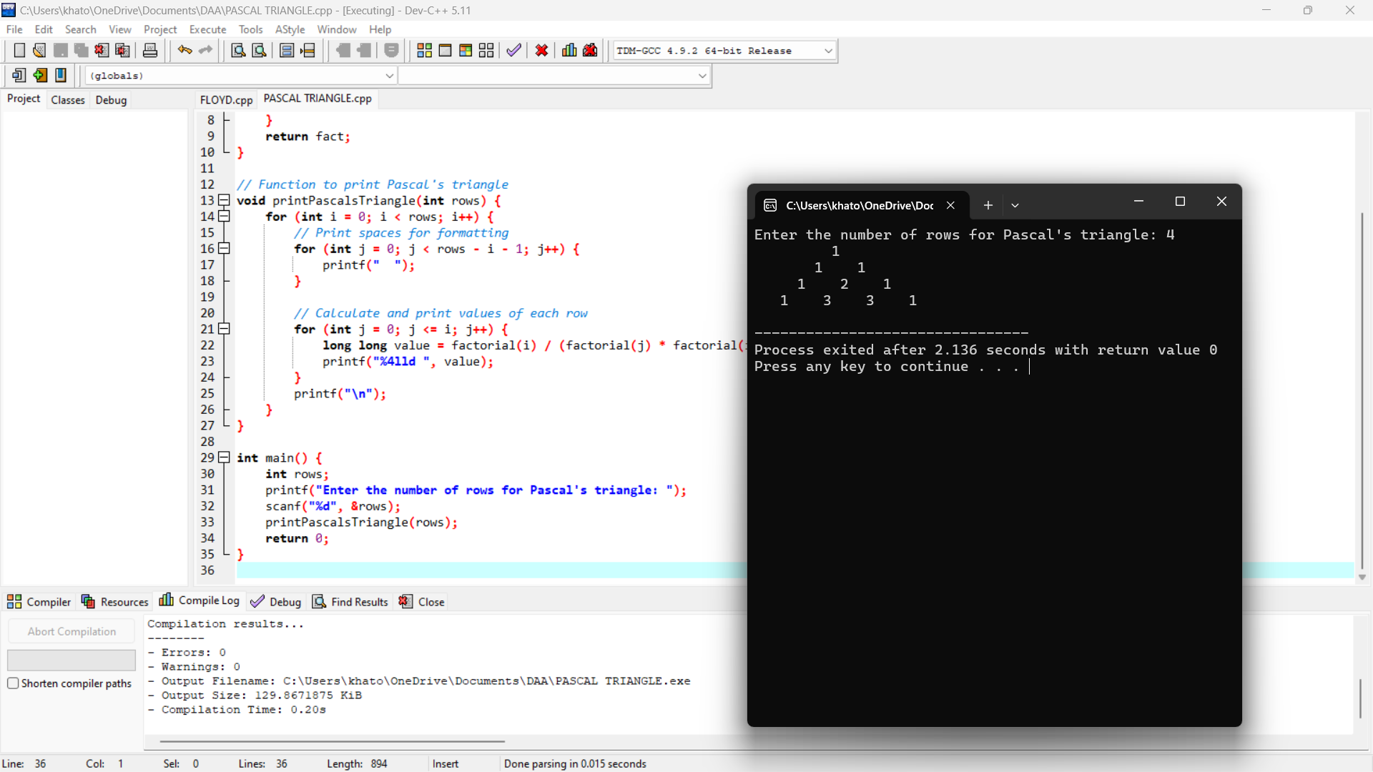

OPTIMAL COST USING KNAPSACK

#include <stdio.h>

// Function to find the maximum of two numbers

int max(int a, int b) {

return (a > b) ? a : b;

}

// Function to solve the 0/1 Knapsack problem

int knapsack(int capacity, int weights[], int values[], int n) {

int i, w;

int dp[n + 1][capacity + 1]; // Create a 2D DP array

// Build the DP table in a bottom-up manner

for (i = 0; i <= n; i++) {

for (w = 0; w <= capacity; w++) {

if (i == 0 || w == 0) {

dp[i][w] = 0; // Base case: no items or zero capacity

} else if (weights[i - 1] <= w) {

dp[i][w] = max(values[i - 1] + dp[i - 1][w - weights[i - 1]], dp[i - 1][w]);

} else {

dp[i][w] = dp[i - 1][w];

}

}

}

// Return the maximum value that can be put in the knapsack

return dp[n][capacity];

}

int main() {

int n, capacity;

// Input number of items and capacity of knapsack

printf("Enter the number of items: ");

scanf("%d", &n);

printf("Enter the capacity of the knapsack: ");

scanf("%d", &capacity);

int values[n], weights[n];

// Input the values and weights of the items

printf("Enter the values of the items: \n");

for (int i = 0; i < n; i++) {

scanf("%d", &values[i]);

}

printf("Enter the weights of the items: \n");

for (int i = 0; i < n; i++) {

scanf("%d", &weights[i]);

}

// Call the knapsack function and print the optimal cost

int optimal_cost = knapsack(capacity, weights, values, n);

printf("The optimal cost is: %d\n", optimal_cost);

return 0;

}

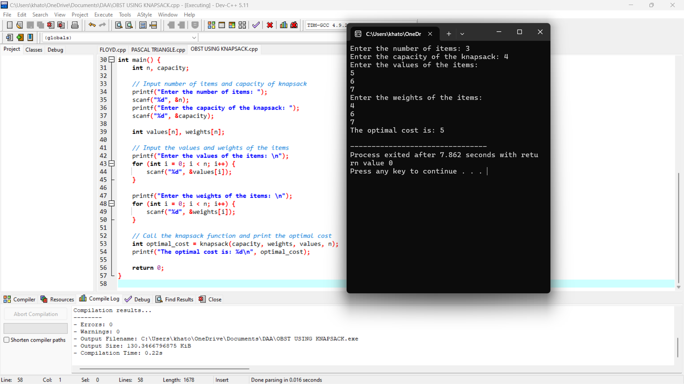

SUM OF DIGITS

#include <stdio.h>

int main() {

int num, sum = 0, remainder;

// Input a number from user

printf("Enter an integer: ");

scanf("%d", &num);

// Loop to find the sum of digits

while (num != 0) {

remainder = num % 10; // Get the last digit

sum += remainder; // Add it to sum

num /= 10; // Remove the last digit

}

// Output the sum of digits

printf("Sum of digits = %d\n", sum);

return 0;

}

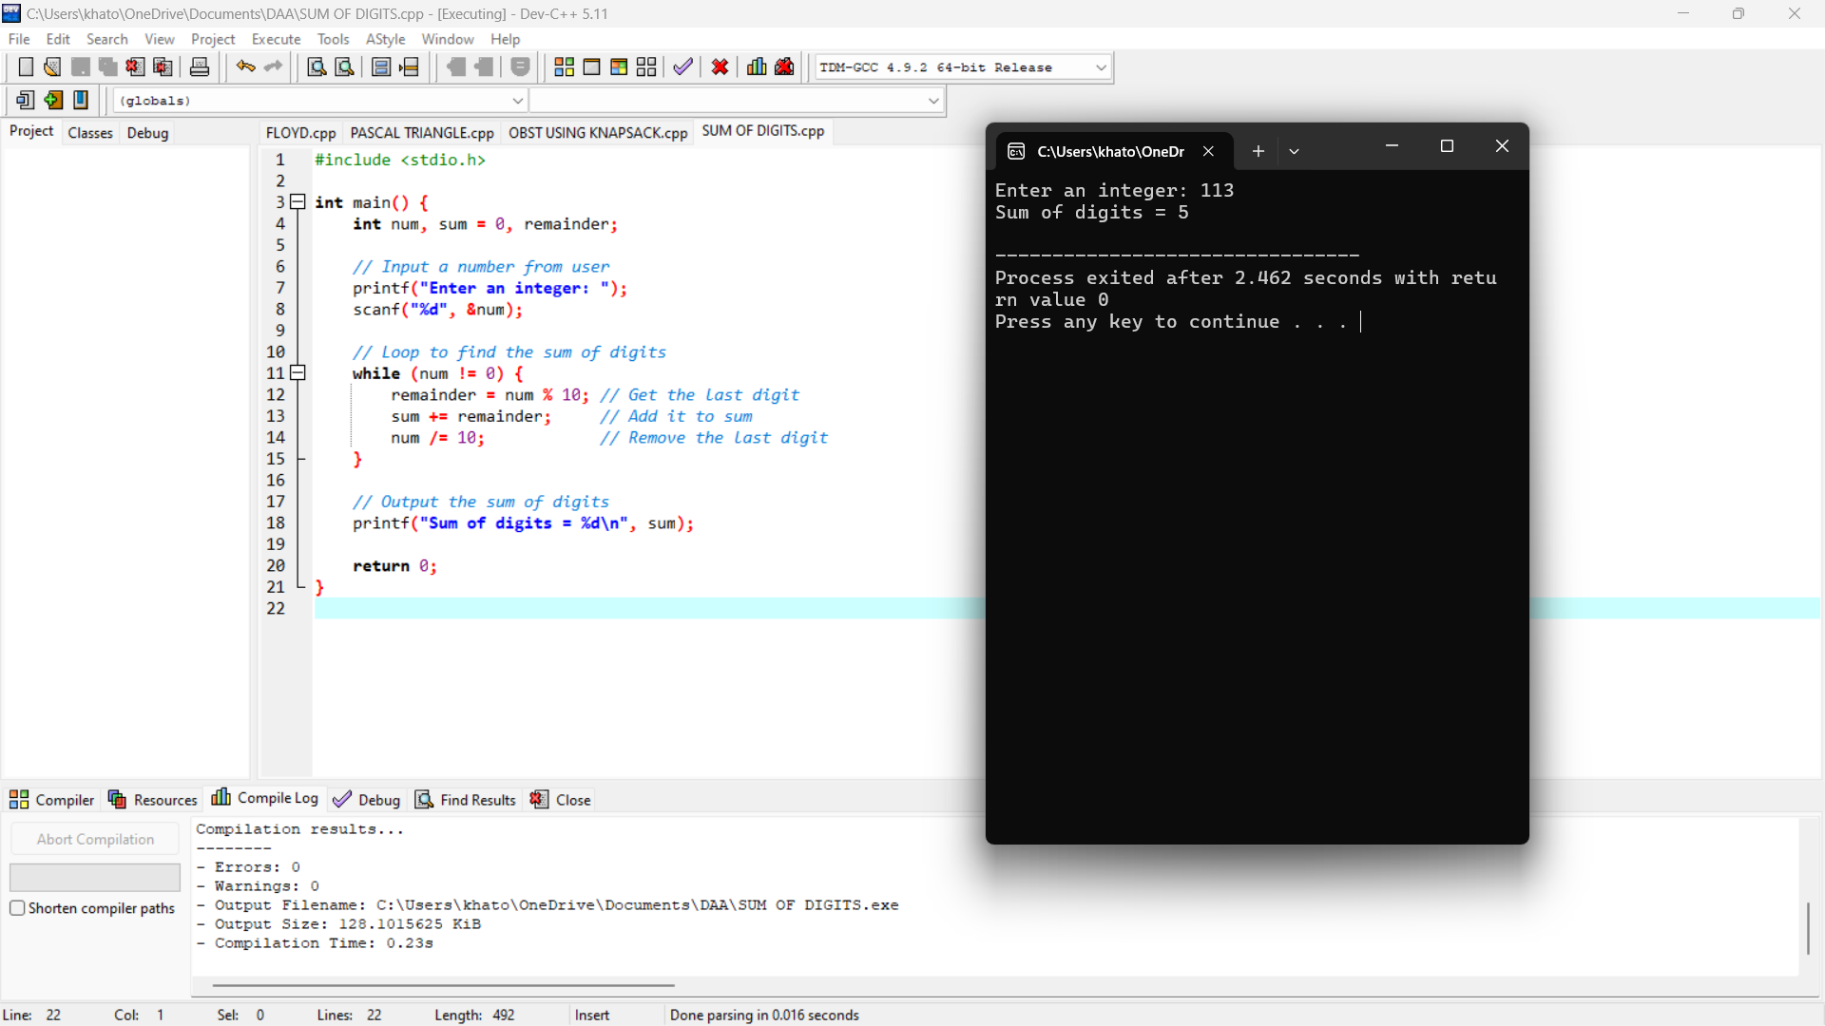

MAX ND MIN IN LIST

#include <stdio.h>

int main() {

int n, i;

int max, min;

// Ask the user for the number of elements

printf("Enter the number of elements in the array: ");

scanf("%d", &n);

int arr[n];

// Ask the user to enter the elements of the array

printf("Enter %d elements: \n", n);

for (i = 0; i < n; i++) {

scanf("%d", &arr[i]);

}

// Initialize max and min with the first element

max = min = arr[0];

// Loop through the array to find max and min

for (i = 1; i < n; i++) {

if (arr[i] > max) {

max = arr[i];

}

if (arr[i] < min) {

min = arr[i];

}

}

// Output the max and min

printf("Maximum element: %d\n", max);

printf("Minimum element: %d\n", min);

return 0;

}

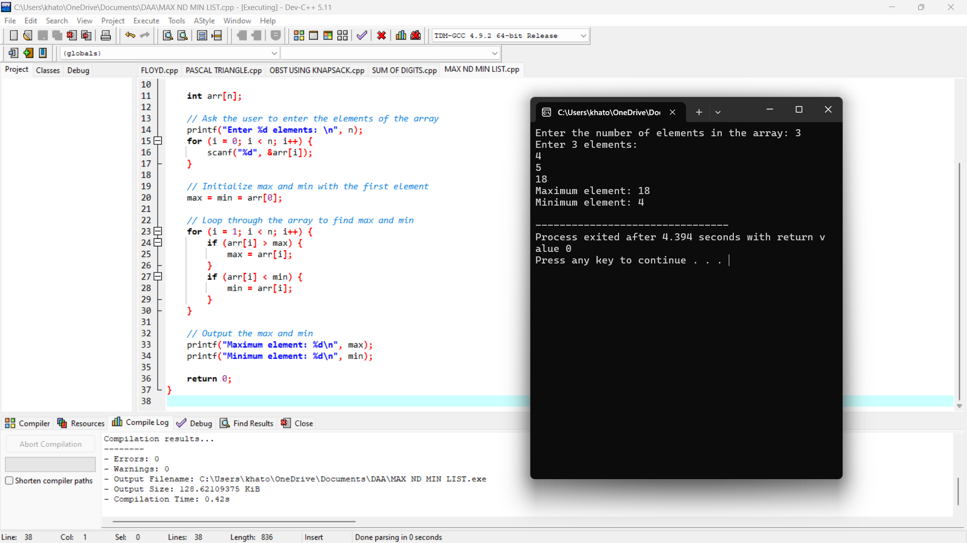

N QUEENS USING BACKTRACKING

#include <stdio.h>

#include <stdbool.h>

#define N 8 // You can change this value for a different size board

// Function to print the solution

void printSolution(int board[N][N]) {

for (int i = 0; i < N; i++) {

for (int j = 0; j < N; j++) {

printf("%d ", board[i][j]);

}

printf("\n");

}

}

// Function to check if a queen can be placed on board[row][col]

bool isSafe(int board[N][N], int row, int col) {

int i, j;

// Check this row on left side

for (i = 0; i < col; i++)

if (board[row][i])

return false;

// Check upper diagonal on left side

for (i = row, j = col; i >= 0 && j >= 0; i--, j--)

if (board[i][j])

return false;

// Check lower diagonal on left side

for (i = row, j = col; j >= 0 && i < N; i++, j--)

if (board[i][j])

return false;

return true;

}

// Function to solve the N-Queens problem using backtracking

bool solveNQueensUtil(int board[N][N], int col) {

// Base case: If all queens are placed, return true

if (col >= N)

return true;

// Consider this column and try placing this queen in all rows one by one

for (int i = 0; i < N; i++) {

// Check if the queen can be placed on board[i][col]

if (isSafe(board, i, col)) {

// Place the queen

board[i][col] = 1;

// Recur to place the rest of the queens

if (solveNQueensUtil(board, col + 1))

return true;

// If placing queen in board[i][col] doesn't lead to a solution, remove the queen

board[i][col] = 0; // BACKTRACK

}

}

// If the queen cannot be placed in any row in this column, return false

return false;

}

// Function to solve the N-Queens problem

bool solveNQueens() {

int board[N][N] = {0}; // Initialize the board with 0s

if (solveNQueensUtil(board, 0) == false) {

printf("Solution does not exist\n");

return false;

}

printSolution(board);

return true;

}

// Driver code

int main() {

solveNQueens();

return 0;

}

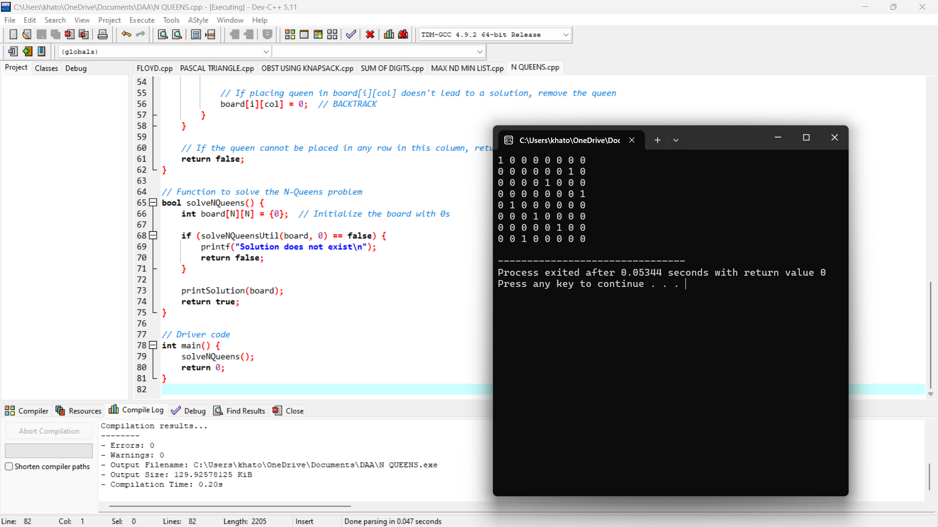

**33. INSERT A NUMBER IN LIST**

#include <stdio.h>

void insertNumber(int arr[], int *size, int number) {

int i, j;

// Find the correct position for the number

for (i = 0; i < *size; i++) {

if (arr[i] > number) {

break;

}

}

// Shift elements to the right to make space for the new number

for (j = *size; j > i; j--) {

arr[j] = arr[j - 1];

}

// Insert the number

arr[i] = number;

(*size)++; // Increment the size of the array

}

int main() {

int arr[100], size, i, number;

// Get the size of the array

printf("Enter the number of elements in the array: ");

scanf("%d", &size);

// Get the elements of the array

printf("Enter %d elements in sorted order: \n", size);

for (i = 0; i < size; i++) {

scanf("%d", &arr[i]);

}

// Get the number to insert

printf("Enter the number to insert: ");

scanf("%d", &number);

// Insert the number in the correct position

insertNumber(arr, &size, number);

// Print the updated array

printf("Array after insertion: \n");

for (i = 0; i < size; i++) {

printf("%d ", arr[i]);

}

printf("\n");

return 0;

}

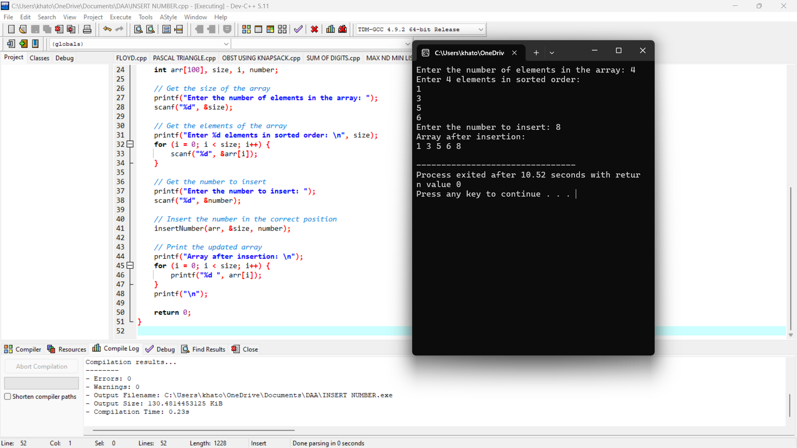

**34. SUM OF SUBSETS**

#include <stdio.h>

// Function to print a subset

void printSubset(int subset[], int size) {

int sum = 0;

printf("{ ");

for (int i = 0; i < size; i++) {

printf("%d ", subset[i]);

sum += subset[i];

}

printf("} -> Sum = %d\n", sum);

}

// Recursive function to find the subsets

void findSubsets(int set[], int subset[], int n, int subsetSize, int index) {

if (index == n) {

printSubset(subset, subsetSize);

return;

}

// Including set[index] in the current subset

subset[subsetSize] = set[index];

findSubsets(set, subset, n, subsetSize + 1, index + 1);

// Not including set[index] in the current subset

findSubsets(set, subset, n, subsetSize, index + 1);

}

int main() {

int n;

printf("Enter the number of elements in the set: ");

scanf("%d", &n);

int set[n], subset[n];

printf("Enter the elements of the set:\n");

for (int i = 0; i < n; i++) {

scanf("%d", &set[i]);

}

printf("The subsets and their sums are:\n");

findSubsets(set, subset, n, 0, 0);

return 0;

}

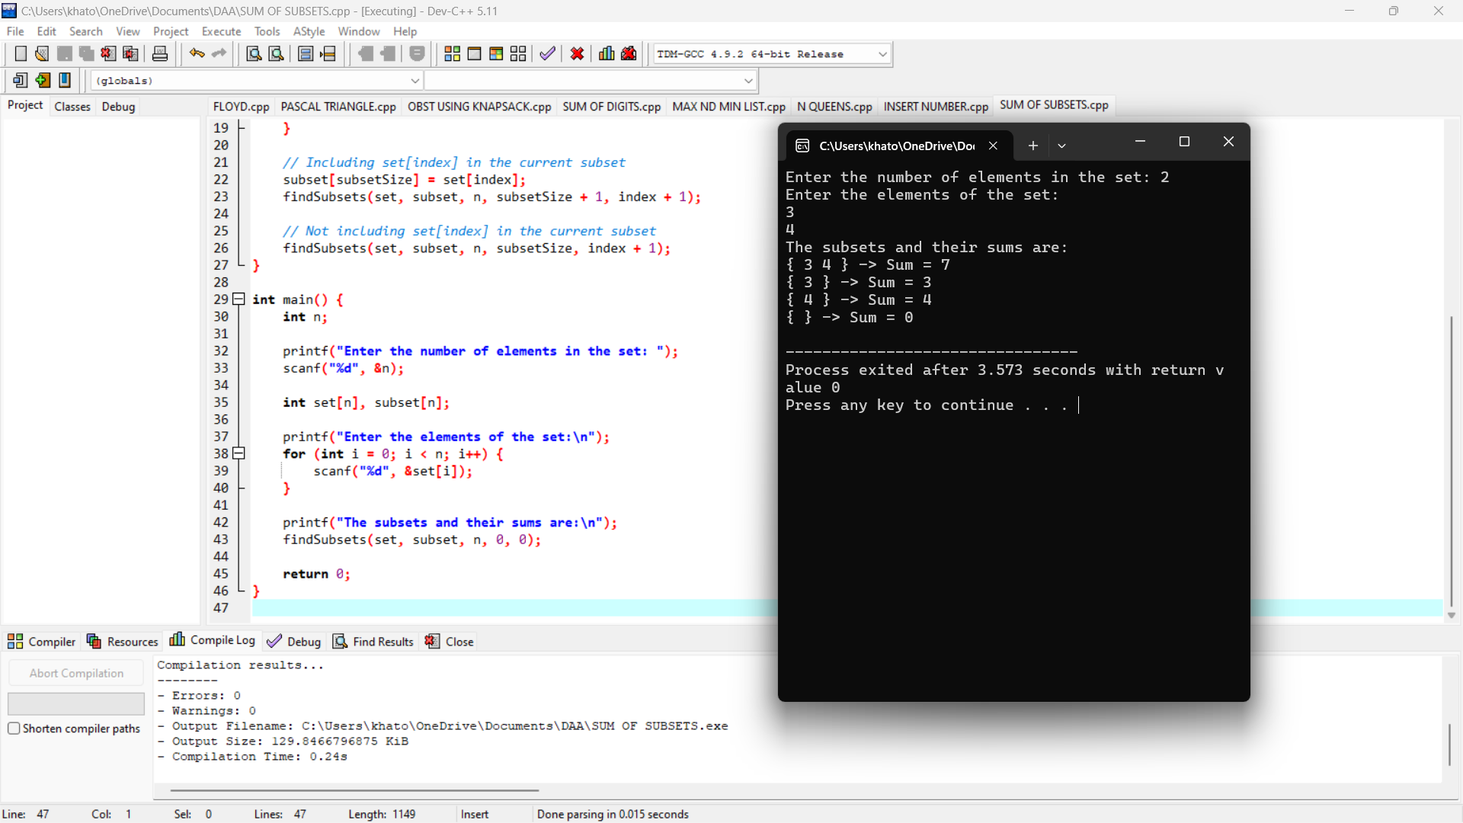

**35. GRAPH COLORING**

#include <stdio.h>

#include <stdbool.h>

#define V 4 // Number of vertices

// Function to print the solution

void printSolution(int color[]) {

printf("Solution exists: Following are the assigned colors:\n");

for (int i = 0; i < V; i++)

printf("Vertex %d ---> Color %d\n", i, color[i]);

}

// Function to check if the current color assignment is safe

bool isSafe(int v, bool graph[V][V], int color[], int c) {

for (int i = 0; i < V; i++) {

if (graph[v][i] && c == color[i]) // If adjacent and color is the same

return false;

}

return true;

}

// A recursive utility function to solve the graph coloring problem

bool graphColoringUtil(bool graph[V][V], int m, int color[], int v) {

// Base case: If all vertices are assigned a color then return true

if (v == V)

return true;

// Consider this vertex v and try different colors

for (int c = 1; c <= m; c++) {

// Check if assignment of color c to v is valid

if (isSafe(v, graph, color, c)) {

color[v] = c;

// Recursively assign colors to the rest of the vertices

if (graphColoringUtil(graph, m, color, v + 1))

return true;

// If assigning color c doesn't lead to a solution, remove it

color[v] = 0;

}

}

// If no color can be assigned, return false

return false;

}

// Function to solve the m Coloring problem

bool graphColoring(bool graph[V][V], int m) {

// Initialize all color values as 0 (unassigned)

int color[V] = {0};

// Call graphColoringUtil() for vertex 0

if (graphColoringUtil(graph, m, color, 0) == false) {

printf("Solution does not exist\n");

return false;

}

// Print the solution

printSolution(color);

return true;

}

int main() {

// Example graph (4 vertices)

bool graph[V][V] = {

{0, 1, 1, 1},

{1, 0, 1, 0},

{1, 1, 0, 1},

{1, 0, 1, 0},

};

int m = 3; // Number of colors

// Check if the solution exists

graphColoring(graph, m);

return 0;

}

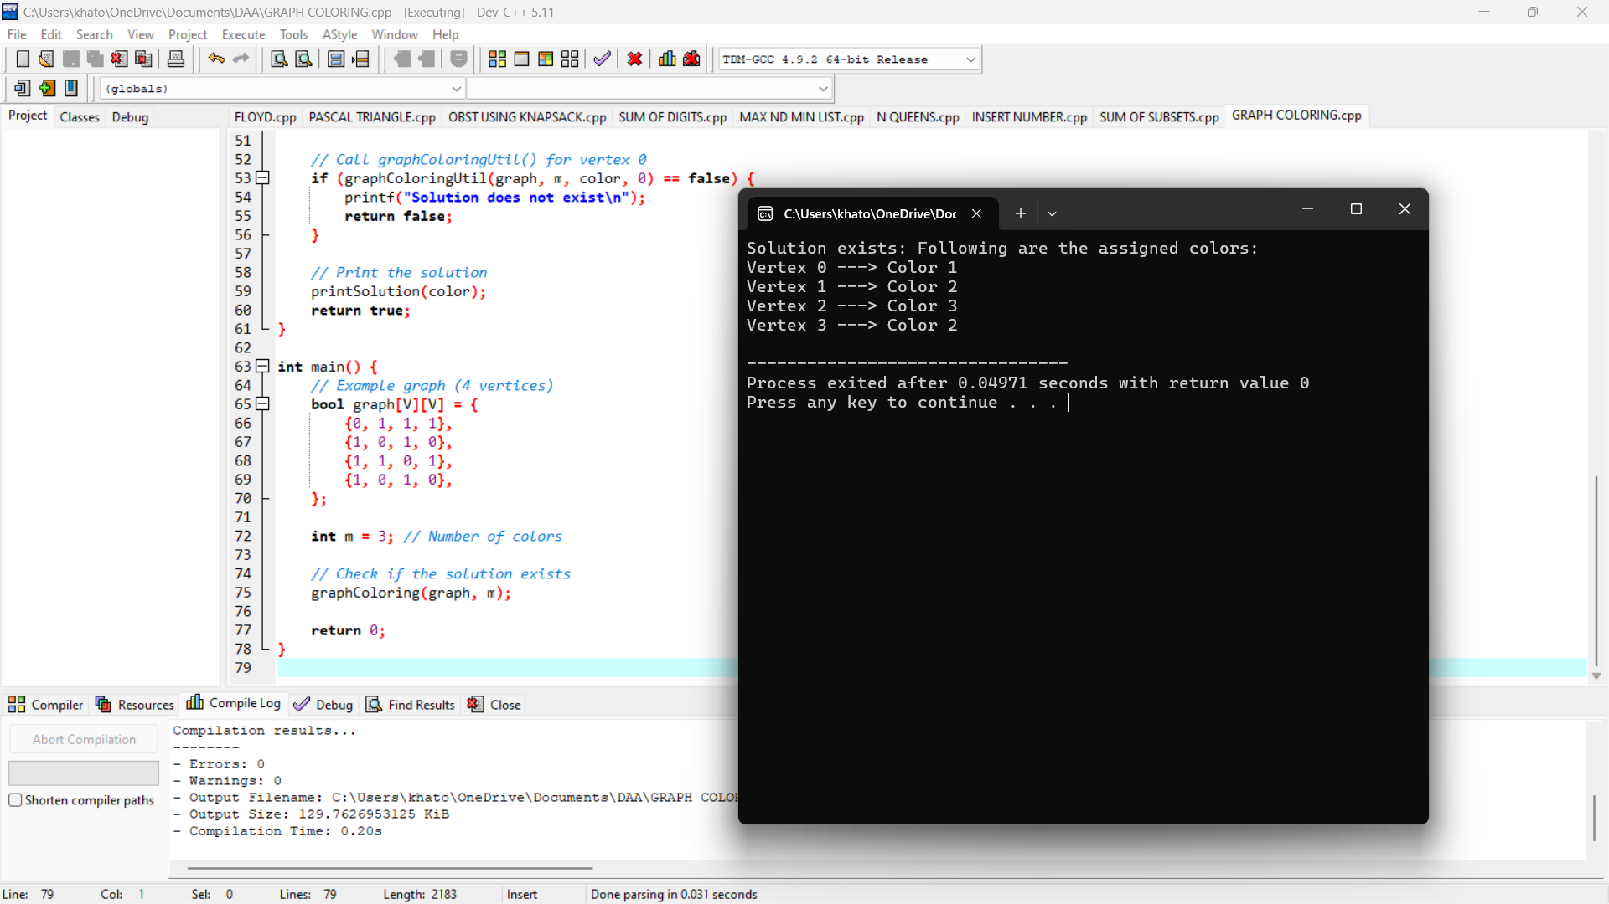

36. CONTAINER LOADER

#include <stdio.h>

#define MAX_ITEMS 100

#define MAX_CONTAINERS 100

void firstFit(int items[], int n, int containerCapacity) {

int containers[MAX_CONTAINERS] = {0}; // Array to store remaining capacity of containers

int containerCount = 0;

for (int i = 0; i < n; i++) {

int j;

// Try to fit the item in an existing container

for (j = 0; j < containerCount; j++) {

if (containers[j] >= items[i]) {

containers[j] -= items[i];

printf("Item %d of weight %d placed in container %d\n", i+1, items[i], j+1);

break;

}

}

// If it doesn't fit in any existing container, use a new one

if (j == containerCount) {

containers[containerCount] = containerCapacity - items[i];

printf("Item %d of weight %d placed in new container %d\n", i+1, items[i], containerCount+1);

containerCount++;

}

}

printf("\nTotal containers used: %d\n", containerCount);

}

int main() {

int items[MAX_ITEMS];

int n, containerCapacity;

// Input: number of items and container capacity

printf("Enter the number of items: ");

scanf("%d", &n);

printf("Enter the container capacity: ");

scanf("%d", &containerCapacity);

// Input: weight of each item

printf("Enter the weights of the items:\n");

for (int i = 0; i < n; i++) {

printf("Item %d: ", i+1);

scanf("%d", &items[i]);

}

// Call the function to find the container loading solution

firstFit(items, n, containerCapacity);

return 0;

}

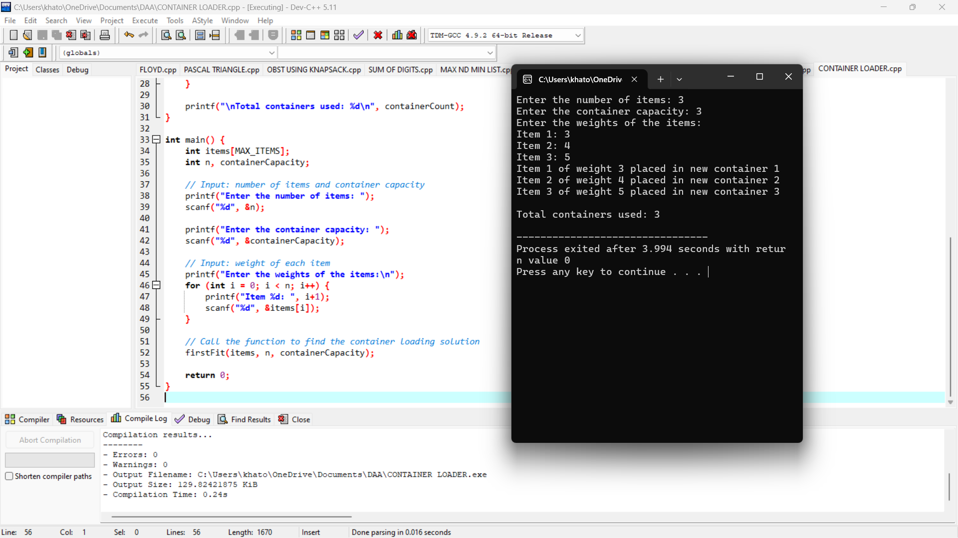

**37. LIST OF ALL FACTOR**

#include <stdio.h>

void findFactors(int n) {

printf("Factors of %d are: ", n);

for (int i = 1; i <= n; i++) {

if (n % i == 0) {

printf("%d ", i);

}

}

printf("\n");

}

int main() {

int n;

printf("Enter a positive integer: ");

scanf("%d", &n);

if (n <= 0) {

printf("Please enter a positive integer.\n");

} else {

findFactors(n);

}

return 0;

}

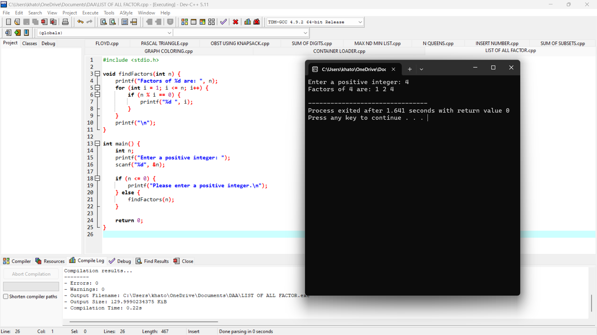

**38. BRANCH AND BOUND**

#include <stdio.h>

#include <limits.h>

#include <stdbool.h>

#define N 4 // Number of cities

int costMatrix[N][N] = {

{0, 10, 15, 20},

{10, 0, 35, 25},

{15, 35, 0, 30},

{20, 25, 30, 0}

};

int finalRes = INT_MAX;

int finalPath[N + 1];

void TSP(int currPos, int n, int count, int cost, int path[]) {

if (count == n && cost + costMatrix[currPos][0] < finalRes) {

finalPath[count] = 0;

finalRes = cost + costMatrix[currPos][0];

return;

}

for (int i = 0; i < n; i++) {

if (i != currPos && path[i] == 0) {

int temp = cost + costMatrix[currPos][i];

if (temp < finalRes) {

path[i] = 1;

TSP(i, n, count + 1, temp, path);

path[i] = 0; // Backtrack

}

}

}

}

int main() {

int path[N] = {0}; // Initialize path array

path[0] = 1; // Start from the first city

TSP(0, N, 1, 0, path); // Start TSP from city 0

printf("Minimum cost: %d\n", finalRes);

printf("Path: ");

for (int i = 0; i <= N; i++) {

printf("%d ", finalPath[i]);

}

printf("\n");

return 0;

}

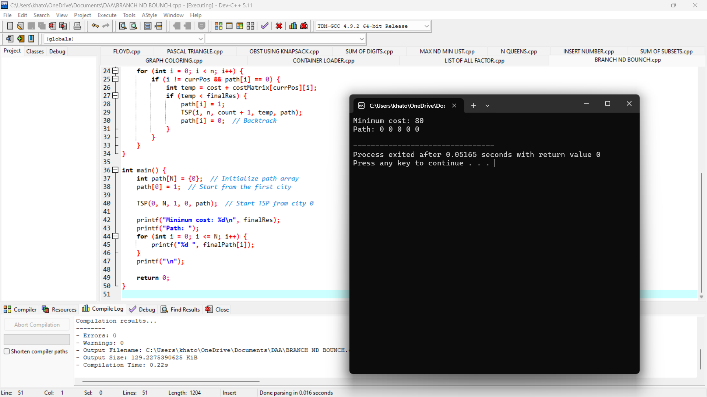

**39. LINEAR SEARCH**

#include <stdio.h>

// Function for linear search

int linearSearch(int arr[], int size, int target) {

for (int i = 0; i < size; i++) {

if (arr[i] == target) {

return i; // Return the index if found

}

}

return -1; // Return -1 if not found

}

int main() {

int arr[] = {2, 4, 0, 1, 9, 6};

int size = sizeof(arr) / sizeof(arr[0]);

int target;

printf("Enter the number to search: ");

scanf("%d", &target);

int result = linearSearch(arr, size, target);

if (result != -1) {

printf("Element found at index: %d\n", result);

} else {

printf("Element not found in the array.\n");

}

return 0;

}

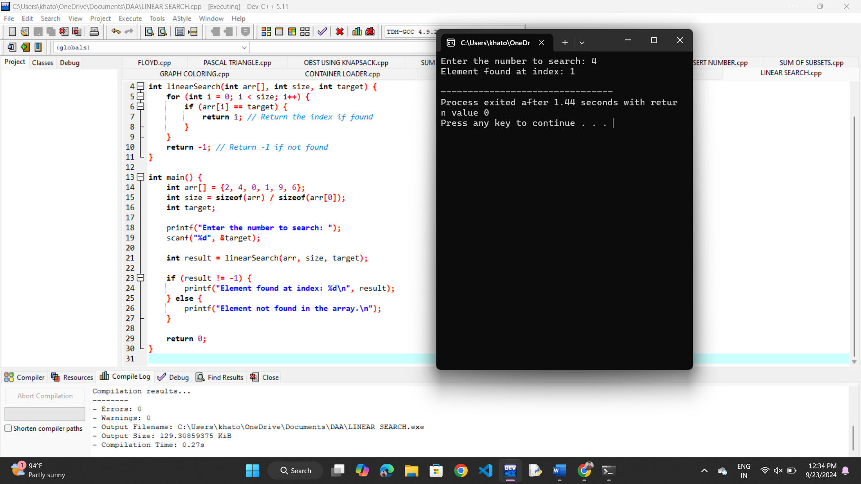

**40. HAMILTONIAN**

#include <stdio.h>

#include <stdbool.h>

#define V 5 // Number of vertices in the graph

bool isSafe(int graph[V][V], int path[], int pos, int v) {

// Check if this vertex is an adjacent vertex of the previously added vertex.

if (graph[path[pos - 1]][v] == 0) {

return false;

}

// Check if the vertex has already been included in the path.

for (int i = 0; i < pos; i++) {

if (path[i] == v) {

return false;

}

}

return true;

}

bool hamCycleUtil(int graph[V][V], int path[], int pos) {

// Base case: If all vertices are included in the path

if (pos == V) {

// And if there is an edge from the last included vertex to the first vertex

return graph[path[pos - 1]][path[0]] == 1;

}

// Try different vertices as the next candidate in the Hamiltonian Path

for (int v = 1; v < V; v++) {

if (isSafe(graph, path, pos, v)) {

path[pos] = v;

if (hamCycleUtil(graph, path, pos + 1)) {

return true;

}

// Backtrack

path[pos] = -1;

}

}

return false;

}

void findHamiltonianCycle(int graph[V][V]) {

int path[V];

for (int i = 0; i < V; i++) {

path[i] = -1;

}

// Start from the first vertex

path[0] = 0;

if (!hamCycleUtil(graph, path, 1)) {

printf("No Hamiltonian Cycle found\n");

} else {

printf("Hamiltonian Cycle found:\n");

for (int i = 0; i < V; i++) {

printf("%d ", path[i]);

}

printf("%d\n", path[0]); // to show the cycle

}

}

int main() {

// Example graph (adjacency matrix representation)

int graph[V][V] = {

{0, 1, 0, 1, 0},

{1, 0, 1, 0, 1},

{0, 1, 0, 1, 0},

{1, 0, 1, 0, 1},

{0, 1, 0, 1, 0}

};

findHamiltonianCycle(graph);

return 0;

}

